SMARTFIT

DESIGN AND IMPLEMENTATION OF A VIRTUAL FITTING ROOM FOR ONLINE FASHION RETAILERS IN KENYA USING COMPUTER VISION

CHRISTOPHER MAINA MACHARIA
SCT221-0778/2022
SUPERVISOR: DR. DENNIS NJAGI

A Research Project Proposal Submitted to the Department of Computing and Information Technology in the School of Open Distance and E-Learning in Partial Fulfillment of the Requirements for the Award of the Degree of Bachelor of Science in Information Technology - Jomo Kenyatta University of Agriculture and Technology.

2026

DECLARATION

This proposal/research project is my original work and has not been presented for a degree in any other University

………………………….. ……………………….
Signature Date

This proposal/research project has been submitted for examination with my approval as University Supervisor

…………………………….. ……………………….
Signature Date

ABSTRACT
Online clothing shopping has become increasingly popular in Kenya due to the growth of e-commerce platforms and social media-based fashion businesses. However, one of the major challenges faced by customers is the difficulty of determining whether a garment will fit properly before purchase. This can result in incorrect size selection, product returns, additional delivery costs, and reduced customer satisfaction. The challenge is particularly relevant to local online fashion retailers who may have limited access to technological tools that can assist customers in making informed clothing purchase decisions.
This project proposes the design and implementation of SmartFit, a computer vision-based virtual fitting system for online fashion retailers in Kenya. The system will allow users to upload short rotational body videos, which will be processed using OpenCV and MediaPipe to detect body landmarks and estimate selected body measurements. The estimated measurements will be used to generate scaled digital avatars for virtual fitting representation. Retailers will be able to register garments and provide their dimensions, which will be compared with user measurements to determine garment fit and provide clothing size recommendations. Three.js will be used to provide simplified three-dimensional visualization of the digital avatar and selected garments.
The project will adopt the Agile software development methodology to support iterative system development, testing, and refinement. Data will be collected through literature review, interviews, and questionnaires involving online fashion shoppers and small-scale online clothing retailers in Kenya. The system will be implemented as a web-based application using React for the frontend, FastAPI and Python for backend services, OpenCV and MediaPipe for computer vision and body measurement processing, Three.js for three-dimensional visualization, and PostgreSQL for data storage. Functional and usability testing will be conducted to evaluate the system's operation, usability, and perceived accuracy.
The expected outcome is a functional software prototype that enables customers to assess garment suitability before purchase through body measurement estimation, digital avatar generation, garment matching, size recommendation, and simplified virtual fitting visualization. The system is intended to support more informed online clothing purchase decisions and provide local online fashion retailers with an accessible technological solution for improving the virtual shopping experience.

TABLE OF CONTENTS
DECLARATION 1
ABSTRACT 2
TABLE OF CONTENTS 4
CHAPTER ONE: INTRODUCTION 1
1.1 Background 1
1.3 Statement of the Problem 5
1.4 Proposed Solution 7
1.5 Objectives 8
1.5.1 Main Objective 8
1.5.2 Specific Objectives 8
1.6 Research Questions 9
1.7 Justification of the Study 10
1.8 Proposed System Methodology 12
1.8.1 Software Development Methodology 13
1.8.2 Data Collection Methods 15
1.8.3 System Design Approach 16
1.8.4 Tools and Technologies 17
1.8.5 Testing and Evaluation 19
1.9 Scope of the Study 20
CHAPTER TWO: LITERATURE REVIEW 21
2.1 Introduction 21
2.2 Theoretical Review 22
2.2.1 Computer Vision 23
2.2.2 Human Pose Estimation and Body Landmark Detection 24
2.2.3 Body Measurement Estimation 25
2.2.4 Three-Dimensional Body Modelling and Avatar Generation 26
2.2.5 Three-Dimensional Web Visualization 27
2.2.6 Web-Based Client-Server Architecture 28
2.2.7 Database Management and Data Persistence 29
2.2.8 E-Commerce Personalization and Size Recommendation 30
2.2.9 Integration of Theoretical Concepts 31
2.3 Case Study Review 32
2.3.1 Walmart and Zeekit Virtual Fitting System 33
2.3.2 ASOS Virtual Catwalk and Fit Assistant 34
2.3.3 Amazon Virtual Try-On System 35
2.3.4 Reactive Reality Virtual Dressing Technology 36
2.3.5 Research-Based Virtual Fitting Systems 37
2.3.6 Summary of Case Study Findings 38
2.4 Integration and Architecture 39
2.4.1 Frontend Layer 41
2.4.2 Backend Layer 43
2.4.4 Avatar Generation and Visualization Module 47
2.4.5 Database Layer 49
2.4.6 System Integration Workflow 51
2.5 Summary 53
2.6 Research Gaps 54
CHAPTER THREE: SYSTEM ANALYSIS AND DESIGN 56
3.1 Introduction 56
3.2 System Development Methodology 57
3.3 Feasibility Study 59
3.3.1 Technical Feasibility 60
3.3.2 Economic Feasibility 60
3.3.3 Operational Feasibility 60
3.3.4 Legal Feasibility 61
3.3.5 Schedule Feasibility 61
3.4 Requirement Elicitation 62
3.5 Data Analysis 63
3.6 System Specification 65
3.6.1 Functional Requirements 66
3.6.2 Non-Functional Requirements 68
3.7 Requirement Analysis and Modelling 70
3.7.1 Use Case Analysis 71
3.7.1.1 Use Case Diagram 73
3.7.1.2 Use Case Descriptions 74
3.7.3Activity Diagrams 83
3.7.4 Sequence Diagrams 86
3.8 Logical Design 91
3.8.1 System Architecture 93
Presentation Layer 94
Processing Layer 96
Data Layer 97
3.8.2 Control Flow and Process Design 99
3.8.2.1 Customer Virtual Fitting Process 100
3.8.2.2 Retailer Garment Management Process 102
3.8.2.3 System Control Logic 104
3.8.2.4 Exception Handling 105
3.8.3 Design for Non-Functional Requirements 107
3.8.3.1 Security Design 107
3.8.3.2 Error and Exception Handling 109
3.8.3.3 Design for Performance, Maintainability and Scalability 111
3.8.3.4 Design for Usability and User Experience 112
3.9 Physical Design 114
3.9.1 Database Design 115
3.9.1.1 Entity Relationship Diagram (ERD) 116
3.9.1.2 Entity Descriptions 117
Users 118
Videos 119
BodyMeasurements 120
Avatars 121
Garments 122
VirtualFittings 123
3.9.1.3 Data Dictionary 124
3.9.2 User Interface Design 131
3.9.2.1 Introduction 131
3.9.2.2 Home Page 132
3.9.2.3 User Registration Interface 133
3.9.2.4 User Login Interface 134
3.9.2.5 Customer Dashboard Interface 135
3.9.2.6 Video Upload Interface 136
3.9.2.7 Video Processing Interface 137
3.9.2.8 Avatar Generation Interface 138
3.9.2.9 Virtual Fitting Interface 139
3.9.2.10 Retailer Dashboard Interface 140
3.9.2.11 Garment Upload & Management Interface 141

CHAPTER ONE: INTRODUCTION

1.1 Background

The rapid growth of e-commerce has significantly transformed the global retail industry by enabling consumers to purchase goods and services conveniently through online platforms. In the fashion industry, online clothing shopping has become increasingly popular due to the widespread adoption of smartphones, improved internet accessibility, and the growth of digital payment systems. In Kenya, online fashion retail has experienced notable expansion through platforms such as Jumia, Kilimall, Instagram shops, Facebook marketplaces, and independent online fashion stores. Despite this growth, online clothing retail continues to face major challenges related to clothing fit and size accuracy.
Unlike physical retail stores where customers can physically try on garments before purchasing, online shopping does not provide customers with an accurate way of determining whether clothes will fit properly or appear suitable on their body type. Consequently, many consumers purchase clothing items that are either too small, too large, or visually unsuitable. This problem contributes to increased product returns, customer dissatisfaction, reduced consumer confidence, and financial losses for retailers. According to Shin and Baytar (2023), uncertainty regarding clothing size and fit remains one of the major barriers affecting consumer confidence in online fashion shopping.
To address these challenges, researchers and technology companies have increasingly explored virtual fitting room technologies. Virtual fitting rooms use technologies such as computer vision, artificial intelligence, augmented reality, and three-dimensional (3D) modeling to simulate how garments may appear on users before purchase. Existing solutions allow customers to visualize clothing items digitally using avatars, body models, or augmented overlays (Gupta & Thakur, 2022).
Recent advancements in computer vision have enabled the use of video-based body analysis for estimating body measurements and reconstructing simplified digital human models. By analyzing short rotational videos captured using ordinary smartphone cameras, computer vision systems can identify body landmarks, estimate body proportions, and generate scaled digital avatars without requiring specialized scanning hardware. This approach provides a more realistic and accurate alternative compared to static image-based estimation methods.
Several international fashion retailers and technology companies have already begun integrating virtual fitting technologies into e-commerce systems. Companies such as Walmart, through its acquisition of Zeekit, introduced virtual fitting technologies that allow users to preview clothing on digital body models with similar body proportions (Walmart Inc., 2022). Similarly, fashion retailers such as ASOS, Zara, and H&M have invested in virtual try-on technologies aimed at improving customer shopping experiences and reducing clothing return rates (Envisioning, 2023). Furthermore, advances in machine learning and computer vision continue to improve the accuracy and realism of virtual fitting systems (Zhang et al., 2025).
Despite these developments, virtual fitting technologies remain limited in many developing countries, including Kenya. Most local online fashion retailers still rely on conventional size charts that fail to account for variations in body shape, clothing design, and individual fitting preferences. Additionally, advanced commercial virtual fitting systems are often expensive and require sophisticated infrastructure that may not be accessible to many local businesses.
This study therefore proposes the design and implementation of SmartFit - a computer vision-based virtual fitting system for online fashion retailers in Kenya. The proposed system will allow users to upload short rotational body videos captured using smartphone cameras. The system will then process the videos to estimate body measurements, generate scaled digital avatars, and compare user body dimensions with garment measurements stored in the system. The application will further provide simplified virtual fitting visualization and clothing size recommendations to assist customers in making more informed purchasing decisions.
The study seeks to contribute toward improving customer confidence in online clothing purchases, reducing product return rates, and promoting the adoption of emerging computer vision technologies within the Kenyan e-commerce and fashion industry.
1.2 Project Overview

The proposed project focuses on the design and implementation of SmartFit - a computer vision-based virtual fitting system for online fashion retailers in Kenya. The system is intended to improve online clothing shopping experiences by enabling customers to virtually assess garment fitting before making purchases. The project aims to address the common challenge of incorrect clothing size selection in online shopping environments, which often leads to customer dissatisfaction and increased product returns.
The proposed system will utilize short rotational body videos captured using ordinary smartphone cameras to estimate user body measurements. Using computer vision techniques, the system will process uploaded videos to identify body landmarks and generate scaled digital avatars representing users’ body structures and proportions. The generated avatars will then be used to simulate how selected garments may fit on users virtually.
The system will also provide a seller module that allows online fashion retailers to register clothing items together with garment dimensions and related fitting information. The uploaded garment data will be stored within the system database and used during the fitting analysis process. By comparing estimated user body measurements with garment dimensions, the system will determine the expected fitting of clothing items and provide size recommendations to users.
The project will be implemented as a web-based application consisting of frontend, backend, database, and computer vision components. The frontend interface will allow customers and sellers to interact with the system, while the backend will handle business logic, video processing, measurement estimation, and fit analysis. Computer vision technologies such as OpenCV and MediaPipe will be used to process user videos and extract body measurements. Three-dimensional visualization technologies will further be used to generate simplified digital avatars and virtual fitting representations.
The final output of the project will be a functional prototype capable of demonstrating video-based body measurement estimation, garment matching, and simplified virtual fitting visualization. The system is expected to improve customer confidence in online clothing purchases and contribute toward the adoption of emerging digital technologies in the Kenyan online fashion industry.

1.3 Statement of the Problem

The rapid growth of online fashion retail in Kenya has increased the convenience and accessibility of purchasing clothing products through digital platforms. However, despite the expansion of e-commerce within the fashion industry, customers still face significant challenges in determining whether clothes purchased online will fit properly or appear suitable before delivery. Unlike physical stores where customers can try on garments before purchasing, online shopping platforms rely heavily on static product images and generalized size charts that often fail to accurately represent individual body proportions and fitting preferences.
As a result, many customers experience difficulties selecting appropriate clothing sizes, leading to the purchase of garments that are either too small, too large, or unsuitable in appearance. This contributes to customer dissatisfaction, increased product returns, additional delivery expenses, and reduced trust in online shopping platforms. The problem is further complicated by inconsistencies in clothing sizes across different brands and sellers, making conventional size charts unreliable for many consumers.
Although some international retailers have adopted virtual fitting technologies using artificial intelligence, computer vision, and augmented reality, such solutions are often expensive, computationally intensive, or dependent on specialized hardware that may not be easily accessible to local online fashion retailers in Kenya. Consequently, most local online clothing businesses still lack affordable and accessible virtual fitting solutions capable of assisting customers during the online purchasing process.
Furthermore, many existing local systems do not effectively utilize modern computer vision techniques to estimate body measurements and provide personalized fitting visualization using devices commonly available to users, such as smartphone cameras. This creates a technological gap within the Kenyan online fashion industry where consumers continue to make clothing purchase decisions with limited fitting guidance.
Therefore, there is a need for a cost-effective and accessible virtual fitting system capable of utilizing short rotational body videos to estimate user body measurements, generate scaled digital avatars, and provide simplified virtual garment fitting visualization and clothing size recommendations. Such a system would improve customer confidence in online clothing purchases while helping online fashion retailers reduce product return rates and improve customer satisfaction.

1.4 Proposed Solution

This project proposes the design and implementation of SmartFit - a computer vision-based virtual fitting system for online fashion retailers in Kenya. The proposed solution aims to provide customers with a more reliable and interactive method of assessing clothing fit before making online purchases.
The system will allow users to capture and upload short rotational body videos using ordinary smartphone cameras. The uploaded videos will be processed using computer vision techniques to identify body landmarks and estimate key body measurements such as height, shoulder width, chest size, waist size, and hip measurements. Based on the estimated measurements, the system will generate scaled digital avatars representing the body proportions of individual users.
In addition to the customer module, the proposed system will provide a seller module that allows online fashion retailers to upload garment information, including clothing images, garment dimensions, and available sizes. The uploaded garment data will be stored within the system database and used during the fitting analysis process.
The proposed solution will further implement a garment matching and fit prediction mechanism that compares user body measurements with garment dimensions to determine the expected fitting of selected clothing items. The system will classify the fitting outcome based on predefined fitting conditions such as tight fit, regular fit, or loose fit. Furthermore, the application will provide simplified virtual fitting visualization by displaying garments on scaled digital avatars to help users visualize how clothing items may appear before purchase.
The system will be implemented as a web-based application using modern software development technologies and computer vision libraries. The proposed solution is expected to improve customer confidence in online shopping, reduce product return rates caused by incorrect size selection, and promote the adoption of intelligent digital technologies within the Kenyan online fashion industry.

1.5 Objectives

1.5.1 Main Objective
The main objective of this study is to design and implement a computer vision-based virtual fitting system for online fashion retailers in Kenya that utilizes short rotational body videos to estimate user body measurements, generate scaled digital avatars, and provide virtual garment fitting visualization and clothing size recommendations.

1.5.2 Specific Objectives
The specific objectives of this study are:
- To develop a module for capturing and processing short rotational body videos and estimating user body measurements using computer vision techniques.
- To generate scaled digital avatars based on the estimated user body measurements.
- To develop a garment registration and management module that allows sellers to provide garment information and dimensions.
- To implement a garment matching and fit prediction mechanism that compares user body measurements with garment dimensions to determine clothing fit and provide size recommendations.
- To develop and evaluate a simplified virtual fitting visualization system and assess its usability in supporting online clothing purchase decisions.

1.6 Research Questions
This study seeks to answer the following research questions:
- How can short rotational body videos be captured and processed using computer vision techniques to estimate user body measurements?
- How can scaled digital avatars be generated from estimated user body measurements?
- How can a garment registration and management module be developed to capture garment information and dimensions from sellers?
- How can user body measurements be matched with garment dimensions to determine clothing fit and provide appropriate size recommendations?
- How can a simplified virtual fitting visualization system be developed, and how usable is it in supporting online clothing purchase decisions?

1.7 Justification of the Study

The increasing adoption of online fashion retail in Kenya has introduced significant convenience to consumers; however, it has also highlighted persistent challenges related to clothing size accuracy and fit prediction. Many online shoppers experience uncertainty when selecting clothing sizes due to the inability to physically try on garments before purchase. This frequently results in incorrect sizing, increased product returns, additional logistics costs, and reduced customer satisfaction. Addressing this challenge is therefore essential for improving the overall effectiveness of online fashion retail systems.
Existing solutions for virtual fitting and size recommendation are predominantly developed and deployed in advanced markets, where they often rely on expensive infrastructure, proprietary technologies, or specialized hardware such as depth sensors and high-performance computing systems. These requirements make such systems less accessible to many local fashion retailers in Kenya, particularly small and medium-sized enterprises that dominate the online fashion sector. As a result, there remains a technological gap in providing affordable and practical virtual fitting solutions within the local context.
This study is justified by the need to develop a cost-effective and accessible alternative that leverages widely available technologies such as smartphone cameras and computer vision techniques. By utilizing short rotational body videos, the proposed system aims to estimate user body measurements, generate digital avatars, and simulate garment fitting without requiring specialized equipment. This approach enhances accessibility while maintaining reasonable accuracy for practical use.
Furthermore, the study contributes to the growing field of computer vision and digital fashion technologies by exploring video-based body measurement estimation and virtual garment visualization techniques. It also provides a foundation for future advancements in augmented reality and virtual reality applications within e-commerce environments.
From a practical perspective, the proposed system is expected to benefit both consumers and online fashion retailers. Customers will be able to make more informed purchasing decisions, while retailers will benefit from reduced product returns, improved customer satisfaction, and increased trust in online shopping platforms. Therefore, this study is both academically significant and practically relevant to the evolving Kenyan digital economy.

1.8 Proposed System Methodology

This section outlines the methodologies that will be adopted in the design and implementation of the proposed computer vision-based virtual fitting system.
The methodology focuses on the software development approach, data collection methods, system design approach, and tools used in the implementation of the system.

1.8.1 Software Development Methodology
The study will adopt the Agile software development methodology. Agile is suitable for this project because it supports iterative development, continuous feedback, and incremental system improvement. The system will be developed in small functional modules, including video processing, body measurement estimation, avatar generation, garment registration, and virtual fitting visualization. Each module will be tested and refined independently before full system integration.

Figure 1: Agile Software Development Methodology
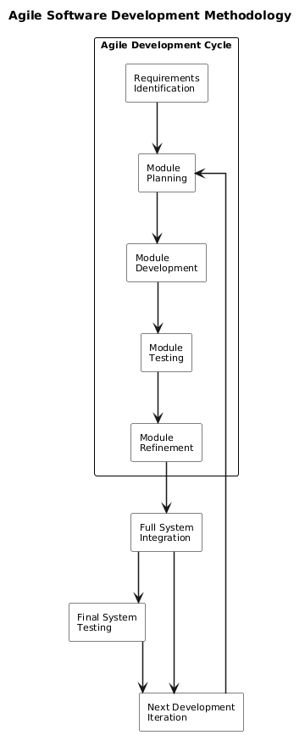

1.8.2 Data Collection Methods
Data will be collected using both primary and secondary sources. Primary data will be obtained through interviews and questionnaires targeting online fashion shoppers and small-scale online clothing retailers in Kenya. This data will help identify user expectations, common challenges in size selection, and usability requirements for the proposed system. Secondary data will be obtained from existing literature, research papers, journals, and online resources related to virtual fitting systems, computer vision, and e-commerce technologies.
Figure 2: Data Collection Methods
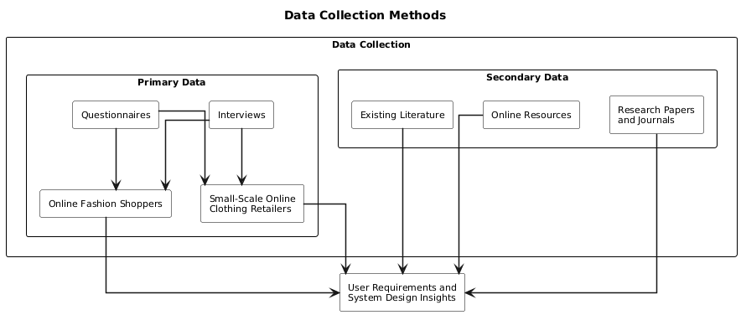

1.8.3 System Design Approach
The system will be designed using a modular architecture consisting of a frontend interface, backend services, a computer vision processing module, and a database management system. The frontend will handle user interaction, while the backend will manage business logic and communication between system components. The computer vision module will process user-uploaded videos to extract body measurements, and the database will store user data, garment information, and system outputs. Unified Modeling Language (UML) diagrams such as use case diagrams, sequence diagrams, and activity diagrams will be used to represent system design.
Figure 3: Modular System Design Approach
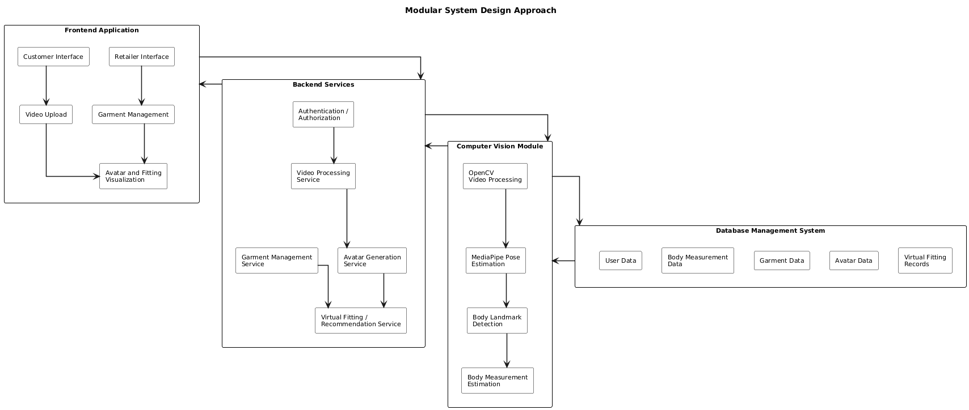

1.8.4 Tools and Technologies
The proposed system will be implemented as a web-based application. The frontend will be developed using React, while the backend will be developed using FastAPI. Computer vision tasks will be implemented using OpenCV and MediaPipe for body landmark detection and measurement estimation. Three-dimensional visualization will be achieved using Three.js for rendering digital avatars and virtual fitting representations. PostgreSQL will be used as the database management system for storing user and garment data.

Figure 4: Tools and Technologies used in the proposed system
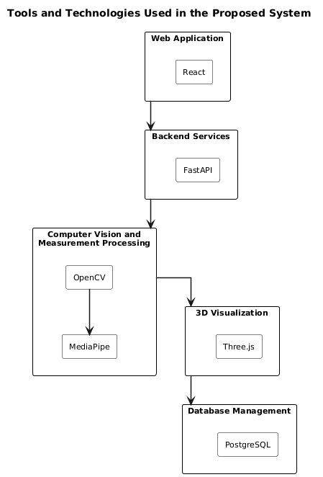

1.8.5 Testing and Evaluation
The system will undergo both functional and usability testing. Functional testing will ensure that all system modules perform as expected, including video processing, measurement estimation, garment matching, and visualization. Usability testing will assess user experience, ease of interaction, and perceived accuracy of the virtual fitting system. The evaluation results will be used to determine the effectiveness of the proposed system in improving online clothing shopping experiences.
Figure 5: Testing and Evaluation Approach
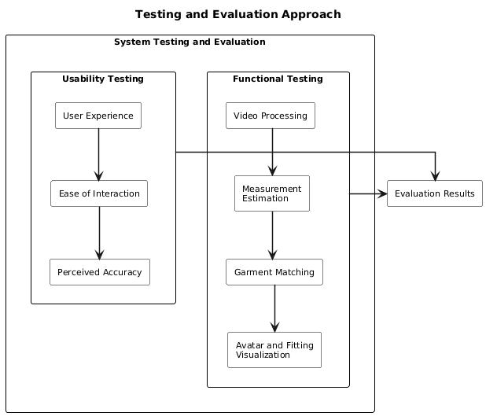

1.9 Scope of the Study
This study focuses on the design and implementation of a computer vision-based virtual fitting system for online fashion retailers in Kenya. The system is intended to improve the accuracy of clothing size selection by enabling users to virtually assess garment fit before making purchase decisions.
The scope of the system is limited to a web-based prototype that allows users to upload short rotational body videos captured using smartphone cameras. The system processes these videos to estimate key body measurements such as height, shoulder width, chest circumference, waist size, and hip measurements using computer vision techniques. Based on the extracted measurements, the system generates a scaled digital avatar representing the user’s body structure.
The study further includes a seller module that allows online fashion retailers to input garment details such as clothing type, size, and physical dimensions. The system compares user body measurements with garment specifications to determine the expected fit, categorized as tight, regular, or loose fit. Additionally, the system provides a simplified virtual visualization of how selected garments would appear on the generated avatar.
The study does not cover advanced features such as real-time 3D cloth physics simulation, high-fidelity garment deformation modeling, or integration with virtual reality headsets. It also does not include medical-grade body scanning accuracy or hardware-based depth sensing technologies. Instead, the system focuses on a software-based approximation approach that balances accuracy, feasibility, and implementation constraints suitable for a final-year academic project.
The target users of the system are online fashion consumers and small to medium-sized online fashion retailers in Kenya. The system is designed as a proof-of-concept prototype and is not intended for full-scale commercial deployment, but rather as a foundation for future enhancement and research in virtual fitting technologies.

CHAPTER TWO: LITERATURE REVIEW

2.1 Introduction

This chapter presents a review of existing literature related to virtual fitting systems, computer vision technologies, digital avatar generation, and online fashion retail systems. The purpose of the literature review is to examine previous studies, existing technologies, methodologies, and research findings relevant to the proposed computer vision-based virtual fitting system for online fashion retailers in Kenya.
The chapter reviews scholarly articles, journals, conference papers, and existing industrial applications associated with virtual garment fitting and body measurement estimation technologies. It further examines the use of computer vision, artificial intelligence, and three-dimensional visualization techniques in improving online shopping experiences. Existing virtual fitting solutions developed by international retailers and technology companies are also analyzed to identify their capabilities, limitations, and applicability within the Kenyan context.
In addition, the chapter explores theoretical and conceptual perspectives related to digital body modeling, video-based body measurement estimation, and garment fit prediction. The review further identifies research gaps in current virtual fitting technologies, particularly regarding accessibility, affordability, and adoption among local online fashion retailers in developing countries.
The findings from the reviewed literature provide the foundation upon which the proposed system is designed and implemented. The chapter therefore establishes the academic and technological basis for the development of the proposed virtual fitting system while highlighting the need for a localized and cost-effective solution for the Kenyan online fashion industry.

2.2 Theoretical Review
This section reviews the theoretical concepts and technologies that provide the foundation for the proposed SmartFit virtual fitting system. The study is primarily grounded in computer vision, human pose estimation, three-dimensional body modelling, three-dimensional visualization, web-based client-server architecture, and E-commerce personalization. These concepts are directly related to the technologies and processing techniques used in the proposed system, including OpenCV, MediaPipe, Three.js, React, FastAPI, and PostgreSQL. Together, these technologies provide the basis for processing user videos, estimating body measurements, generating personalized digital avatars, managing garment information, and presenting virtual fitting results.

2.2.1 Computer Vision
Computer vision is the field of computing concerned with enabling computers to obtain meaningful information from digital images and videos. In the proposed SmartFit system, computer vision provides the foundation for extracting information about a user's body from a short rotational video. Instead of requiring specialized body-scanning hardware, the system processes frames obtained from a smartphone-recorded video to identify relevant body features.
The proposed system will use OpenCV for video processing and frame extraction. OpenCV provides functionality for reading video files, accessing individual frames, and performing image-processing operations. These capabilities are important because the uploaded rotational video must first be converted into usable frames before body landmarks and measurements can be estimated.
Computer vision therefore provides the theoretical foundation for transforming visual information contained in the user's video into structured body data that can subsequently be used by the avatar generation and fitting components.

2.2.2 Human Pose Estimation and Body Landmark Detection
Human pose estimation involves identifying key points or landmarks on the human body from images or video. These landmarks represent anatomical locations such as the shoulders, hips, knees, and other body joints. The spatial relationships between these landmarks can be used to understand body posture and proportions.
SmartFit will use MediaPipe Pose for human pose estimation and body landmark detection. MediaPipe provides a pre-trained pose estimation solution capable of identifying human body landmarks from image frames. The detected landmarks provide the reference points required by the system to approximate body dimensions.
In SmartFit, pose estimation is therefore not used as a standalone feature. It forms part of the measurement-extraction pipeline, where detected body landmarks are processed to estimate relevant measurements such as height, shoulder width, and inseam. These measurements are subsequently used during avatar generation and fitting analysis.

2.2.3 Body Measurement Estimation
Body measurement estimation refers to the process of deriving approximate physical body dimensions from visual information. In a conventional physical fitting environment, measurements can be obtained using a measuring tape or specialized body-scanning equipment. A software-based virtual fitting system instead requires methods for estimating these dimensions from digital visual information.
SmartFit will estimate body measurements from the landmarks detected by MediaPipe. The distances and relationships between relevant landmarks are analysed to obtain approximate body dimensions. The estimated measurements are then stored as structured data in the system database.
The measurement-estimation concept is important because the subsequent stages of SmartFit depend on the relationship between the user's estimated body dimensions and the dimensions of garments registered by retailers. The measurements therefore act as an intermediate representation between video processing, avatar generation, and virtual fitting.

2.2.4 Three-Dimensional Body Modelling and Avatar Generation
Three-dimensional body modelling involves representing a person's physical structure using a digital three-dimensional model. In a virtual fitting system, a digital avatar can provide a visual representation of the user's estimated body characteristics.
SmartFit will use the extracted body measurements to generate a scaled digital avatar representing the user's body proportions. The avatar generation component will use the estimated measurements to determine the appropriate dimensions of the digital model. The resulting avatar is intended to provide a simplified representation suitable for the prototype rather than a highly detailed anatomical reconstruction.
This approach allows the system to connect numerical body measurements with a visual representation of the user. The generated avatar can subsequently be displayed together with garment representations during the virtual fitting process.

2.2.5 Three-Dimensional Web Visualization
Three-dimensional visualization involves displaying and interacting with three-dimensional digital objects within a graphical environment. For SmartFit, this provides the basis for presenting the generated avatar and simplified garment fitting representation to users through a web browser.
The proposed system will use Three.js for browser-based three-dimensional rendering. Three.js provides JavaScript-based functionality for creating scenes, cameras, lighting, and rendering three-dimensional models using WebGL-supported browser environments.
In SmartFit, Three.js will be responsible for displaying the generated digital avatar and simplified garment representations within the frontend. The system will focus on visualizing the relationship between the avatar and garment rather than implementing advanced cloth physics or physically accurate fabric simulation. This approach keeps the visualization appropriate for the scope of the prototype.

2.2.6 Web-Based Client-Server Architecture
Client-server architecture describes a system in which the client provides the user-facing interface while a server provides application services and manages data and processing operations. This architecture is suitable for SmartFit because users interact with the system through a web browser while computational processing and persistent data management are handled by backend services.
The frontend of SmartFit will be developed using React, which will provide the interactive web interface for customers and retailers. The backend will be implemented using FastAPI, which will expose REST-based API endpoints for authentication, video uploads, avatar generation, garment management, and virtual fitting operations.
Communication between the React frontend and FastAPI backend will occur through HTTP-based API requests. This separation allows the user interface and backend processing components to be developed and maintained independently while providing a structured mechanism for exchanging data.

2.2.7 Database Management and Data Persistence
Database management provides the mechanisms required to store, organize, retrieve, and maintain system data. SmartFit requires persistent storage for information generated and used throughout the virtual fitting process.
The system will use PostgreSQL as its relational database management system. PostgreSQL will store user information, uploaded video metadata, estimated body measurements, avatar metadata, garment information, and virtual fitting records.
The relational database provides a structured means of maintaining relationships between users, measurements, avatars, garments, and fitting operations. It also allows the backend to retrieve previously stored information when processing fitting requests.

2.2.8 E-Commerce Personalization and Size Recommendation
E-commerce personalization involves adapting online shopping experiences to information associated with individual users. In clothing e-commerce, one important application is providing size recommendations based on the characteristics of the customer and the dimensions of the available garment.
SmartFit applies this concept by comparing estimated user body measurements with garment dimensions provided by retailers. The fitting component uses these measurements to determine the suitability of a garment and provide a corresponding size recommendation.
This approach addresses one of the limitations of online clothing shopping, where customers cannot physically try on garments before purchase. By combining user-specific body measurements with retailer-provided garment dimensions, the system provides a more personalized method of evaluating garment fit.

2.2.9 Integration of Theoretical Concepts
The concepts discussed above are integrated into SmartFit as a sequential processing pipeline. OpenCV provides video processing and frame extraction, while MediaPipe Pose provides body landmark detection and pose estimation. The extracted landmarks are used to estimate body measurements, which are then used to generate a scaled three-dimensional avatar. Three.js provides browser-based visualization of the avatar and simplified garment representation. React provides the user interface, while FastAPI coordinates application logic and communication between the frontend, processing components, and database. PostgreSQL provides persistent storage for the information generated throughout the workflow.
The integration of these technologies provides the theoretical and technical foundation for the proposed virtual fitting system. Rather than relying on a single technology, SmartFit combines computer vision, pose estimation, three-dimensional modelling, web application technologies, database management, and e-commerce personalization to support the complete virtual fitting workflow.

2.3 Case Study Review
This section reviews existing virtual fitting systems and related technologies developed by international companies and researchers. The purpose of the case study review is to analyze how current systems address clothing fit challenges in online shopping environments, identify the technologies used, and examine the limitations that justify the proposed study.

2.3.1 Walmart and Zeekit Virtual Fitting System
Walmart introduced a virtual fitting technology through its acquisition of Zeekit, a company specializing in digital fitting solutions for online fashion retail. The system allows users to visualize clothing items on digital models with body proportions similar to their own. The platform uses artificial intelligence, computer vision, and image processing technologies to simulate how garments may appear on different body types.
The Zeekit system improved customer confidence in online shopping by allowing users to preview garments before purchase. However, the system primarily relies on predefined body models rather than dynamically generating personalized avatars from user body scans or videos. Additionally, the technology is proprietary and requires significant computational infrastructure, limiting accessibility for smaller retailers and developing markets.

2.3.2 ASOS Virtual Catwalk and Fit Assistant
ASOS introduced digital fitting and visualization technologies aimed at improving online fashion shopping experiences. The company implemented virtual catwalk features and AI-driven size recommendation systems to assist users in selecting suitable clothing sizes. The system uses customer data, previous purchases, and body information to provide personalized size recommendations.
Although the ASOS solution improves customer experience, it mainly focuses on recommendation algorithms rather than direct body measurement extraction or personalized virtual avatar generation. The system also depends heavily on user-input measurements rather than automated body analysis using computer vision technologies.

2.3.3 Amazon Virtual Try-On System
Amazon introduced virtual try-on technologies that allow customers to preview fashion accessories and selected clothing products using augmented reality techniques. The system overlays virtual items onto live camera feeds to simulate product appearance. Amazon’s solution improves product visualization and user interaction during online shopping.
Despite its effectiveness, the system primarily focuses on augmented visualization rather than complete body measurement estimation and personalized garment fit prediction. Additionally, some advanced features require high-performance devices and may not be easily adaptable to low-resource environments.

2.3.4 Reactive Reality Virtual Dressing Technology
Reactive Reality developed a digital dressing room platform that generates personalized avatars and simulates garment fitting using artificial intelligence and three-dimensional modeling technologies. The system allows users to create body profiles and virtually try on clothes before purchase.
The platform demonstrates the growing importance of digital fashion technologies in e-commerce. However, the technology involves advanced infrastructure and computational resources that may not be affordable for many local retailers in developing countries such as Kenya.

2.3.5 Research-Based Virtual Fitting Systems
Several academic studies have explored the use of computer vision and machine learning in virtual fitting systems. Shin and Baytar (2023) examined consumer perceptions of virtual fitting technologies and concluded that such systems improve online shopping confidence and reduce uncertainty in clothing purchases. Zhang et al. (2025) further demonstrated that advances in pose estimation and body landmark detection have improved the feasibility of video-based body measurement estimation systems.
Most existing research focuses on advanced cloth simulation, augmented reality integration, or highly accurate body reconstruction techniques. However, many of these approaches require expensive hardware, high computational power, or specialized scanning devices, limiting their practicality for small-scale online retailers.

2.3.6 Summary of Case Study Findings
The reviewed case studies demonstrate that virtual fitting technologies have significant potential in improving online clothing shopping experiences. Existing systems successfully utilize artificial intelligence, computer vision, and digital visualization to address fitting challenges. However, several limitations remain, including high implementation costs, dependence on proprietary technologies, hardware requirements, and limited accessibility for developing markets.
The reviewed systems also reveal that many current solutions focus either on size recommendation or visual overlay technologies rather than affordable video-based body measurement estimation and simplified personalized avatar generation. These limitations justify the need for the proposed study, which aims to develop a cost-effective and accessible computer vision-based virtual fitting system suitable for online fashion retailers in Kenya.

2.4 Integration and Architecture
This section describes the proposed system architecture and the integration of various technologies and modules required for the implementation of the computer vision-based virtual fitting system. The architecture defines how different system components interact to support video processing, body measurement estimation, avatar generation, garment management, and virtual fitting visualization.
The proposed system will adopt a modular client-server architecture consisting of four major components: the frontend application, backend server, computer vision processing module, and database management system. The modular design approach is intended to improve system scalability, maintainability, and ease of integration between components.

Figure 6: Integration Architecture of the Proposed Virtual Fitting System
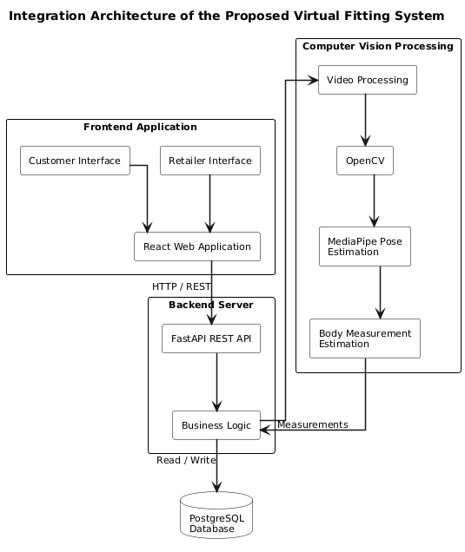

2.4.1 Frontend Layer
The frontend layer will provide the user interface through which customers and sellers interact with the system. The frontend application will be developed using React to support responsive and interactive web interfaces accessible through desktop and mobile web browsers.
The customer interface will allow users to:
- Register and log into the system,
- Upload short rotational body videos,
- View generated avatars,
- Select garments for virtual fitting,
- Receive size recommendations and fitting visualizations.
The seller interface will allow retailers to:
- Register clothing items,
- Upload garment images,
- Enter garment dimensions and size information,
- Manage garment records within the system.
The frontend will communicate with backend services through Application Programming Interfaces (APIs).

Figure 7: Frontend Layer of the Proposed Virtual Fitting System
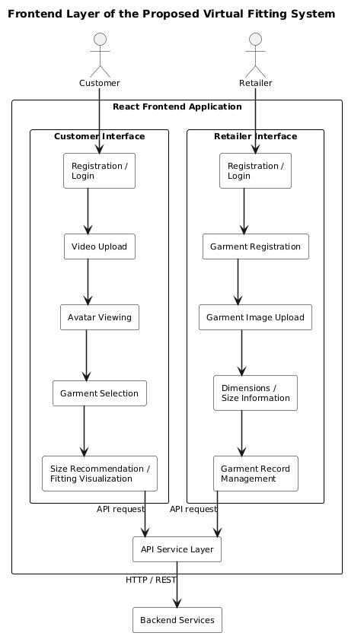

2.4.2 Backend Layer
The backend layer will manage the core business logic of the system. The backend server will be developed using FastAPI due to its efficiency in handling asynchronous requests and integration with machine learning and computer vision libraries.
The backend responsibilities will include:
- User authentication and authorization,
- Video upload handling,
- Communication with the computer vision module,
- Processing garment matching logic,
- Managing avatar generation requests,
- Generating fitting recommendations,
- Handling communication between the frontend and database.
The backend will also coordinate the processing workflow between uploaded user videos and garment data stored in the system.

Figure 8: Backend Layer of the Proposed Virtual Fitting System
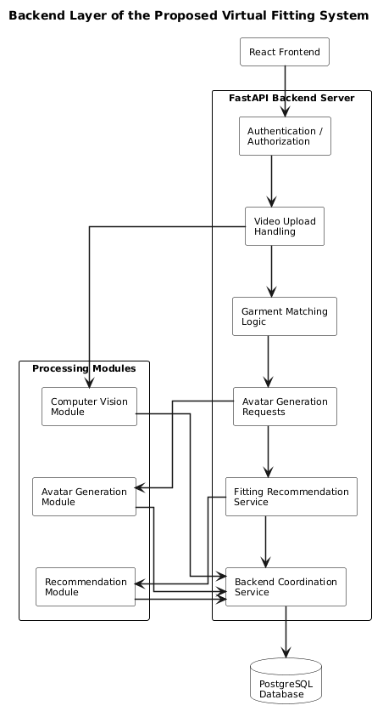
2.4.3 Computer Vision Processing Module
The computer vision module forms the core analytical component of the proposed system. The module will process uploaded short rotational videos to estimate body measurements and body proportions using image processing and pose estimation techniques.
The module will utilize OpenCV and MediaPipe technologies for:
- Video frame extraction,
- Body landmark detection,
- Pose estimation,
- Measurement approximation,
- Body proportion analysis.
The extracted measurements will then be forwarded to the avatar generation and fitting analysis components for further processing.

Figure 9: Computer Vision Processing Module of the Proposed Virtual Fitting System
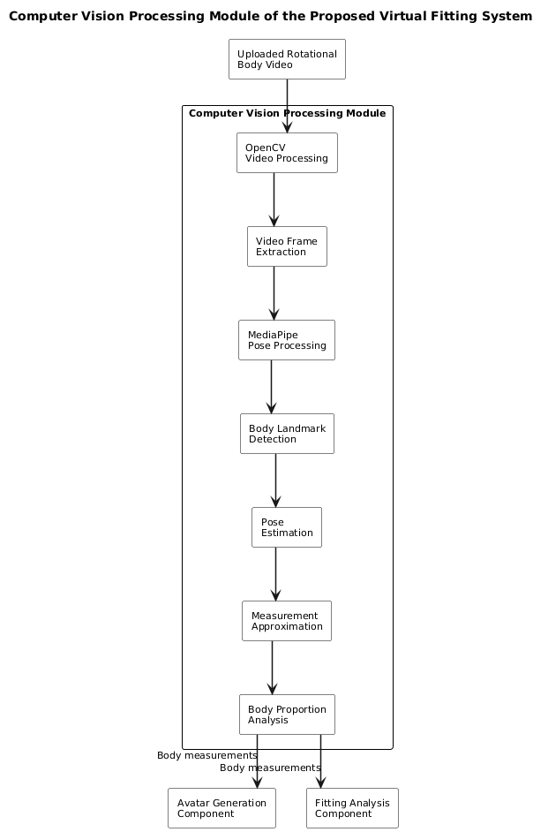

2.4.4 Avatar Generation and Visualization Module
The avatar generation module will create scaled digital avatars based on the estimated body measurements extracted from user videos. The generated avatars will represent simplified digital models of users’ body structures.
The visualization component will utilize Three.js technologies to render three-dimensional avatars and simplified garment fitting representations within the browser environment. The system will not implement advanced cloth physics simulation but will instead provide approximate virtual fitting visualization suitable for prototype implementation.

Figure 10: Avatar Generation and Visualization Module of the Proposed Virtual Fitting System
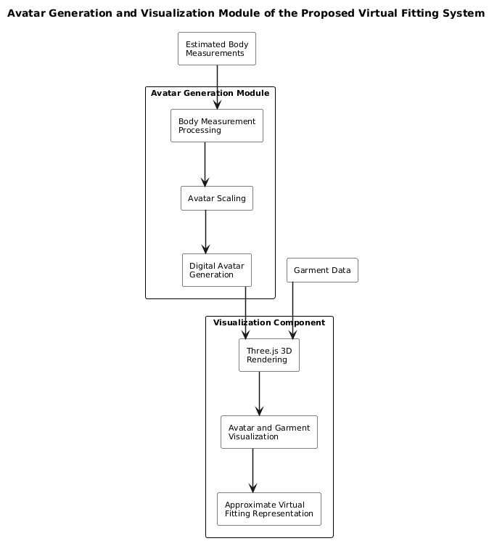

2.4.5 Database Layer
The database layer will be implemented using PostgreSQL to manage system data efficiently. The database will store:
- User information,
- Uploaded garment details,
- Garment dimensions,
- User body measurement data,
- Avatar metadata,
- System activity records.
The database will support data retrieval and synchronization between frontend, backend, and processing modules.

Figure 11: Database Layer of the Proposed Virtual Fitting System
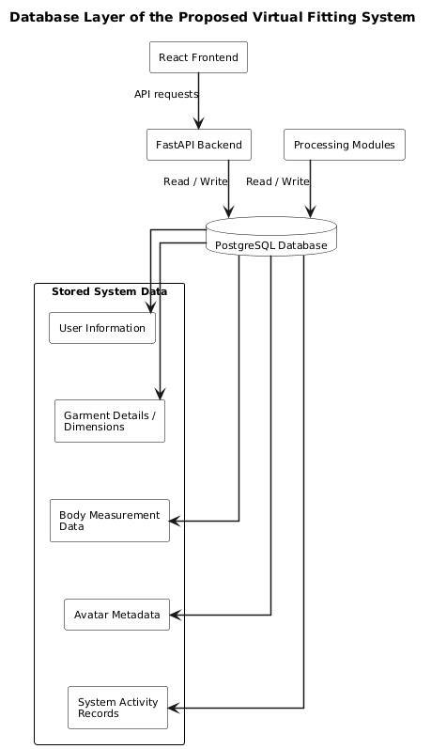

2.4.6 System Integration Workflow
The integrated workflow of the proposed system will operate as follows:
- The user uploads a short rotational body video through the frontend interface.
- The backend server receives the uploaded video and forwards it to the computer vision module.
- The computer vision module extracts body landmarks and estimates body measurements.
- The avatar generation module creates a scaled digital avatar based on the extracted measurements.
- The user selects a garment uploaded by a seller.
- The backend compares garment dimensions with user body measurements to determine fitting suitability.
- The visualization module displays the avatar together with simplified garment fitting representation and provides size recommendations to the user.
The proposed architecture ensures effective communication between all system components while supporting scalability, maintainability, and future enhancement of the virtual fitting system.

Figure 12: System Integration Workflow of the Proposed Virtual Fitting System
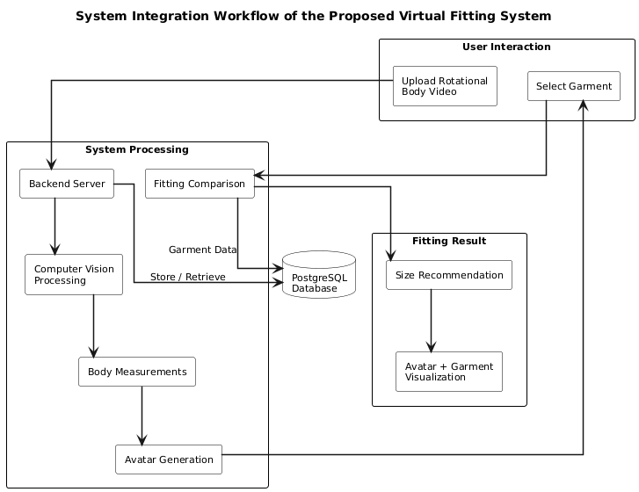

2.5 Summary
This chapter reviewed existing literature, theories, technologies, and case studies related to virtual fitting systems, computer vision, digital avatar generation, and online fashion retail technologies. The literature review established the technological and theoretical foundation necessary for the development of the proposed computer vision-based virtual fitting system.
The chapter examined key theoretical concepts including computer vision theory, three-dimensional body modeling, human-computer interaction, e-commerce personalization, and virtual fitting technologies. These theories demonstrated how modern digital technologies can be utilized to improve online shopping experiences through body measurement estimation, avatar generation, and garment fit visualization.
The chapter further reviewed existing virtual fitting solutions developed by companies such as Walmart, ASOS, Amazon, and Reactive Reality. The reviewed case studies revealed that although current systems have improved online shopping experiences through size recommendation and virtual visualization technologies, many existing solutions remain expensive, proprietary, and dependent on advanced computational infrastructure or specialized hardware. Additionally, most existing systems are not specifically designed for accessibility and affordability within developing markets such as Kenya.
The proposed system architecture and integration framework were also discussed. The chapter outlined how frontend technologies, backend services, computer vision modules, visualization components, and database systems will interact to support video-based body measurement estimation and virtual fitting visualization.
Overall, the literature review identified a gap in the availability of affordable, accessible, and localized virtual fitting systems for online fashion retailers in Kenya. The reviewed literature therefore justifies the need for the proposed study and provides the foundation for the methodology and system implementation discussed in the subsequent chapters.

2.6 Research Gaps
The reviewed literature and existing virtual fitting systems demonstrate significant progress in the application of computer vision, artificial intelligence, and digital visualization technologies within online fashion retail. However, several research and implementation gaps still exist, particularly in relation to accessibility, affordability, localization, and practical deployment within developing countries such as Kenya.
One major gap identified is the heavy dependence of many existing virtual fitting systems on expensive infrastructure and specialized hardware. Several commercial solutions utilize depth sensors, high-resolution body scanners, augmented reality devices, or advanced computational resources that may not be readily available to small and medium-sized online fashion retailers in Kenya. This limits the adoption of such technologies within local e-commerce environments.
Another gap is that many existing systems primarily focus on generalized size recommendation rather than personalized body measurement estimation and avatar generation. Some systems rely heavily on manually entered user measurements or predefined body models instead of dynamically extracting body proportions from user-generated visual input. This reduces personalization and may affect fitting accuracy for users with varying body structures.
The literature review also revealed that many virtual fitting technologies are developed for large international markets and are often implemented using proprietary platforms that are inaccessible to local developers and retailers. Consequently, there is limited research focusing on affordable and adaptable virtual fitting systems specifically designed for the Kenyan online fashion industry and similar developing market contexts.
Furthermore, several existing studies emphasize advanced cloth physics simulation, real-time augmented reality rendering, and highly detailed three-dimensional body reconstruction. While these approaches improve realism, they significantly increase system complexity, computational requirements, and implementation costs. There remains limited research on simplified and practical virtual fitting approaches that balance usability, affordability, and implementation feasibility for academic and small-scale commercial applications.
Additionally, few existing systems effectively utilize short rotational videos captured using ordinary smartphone cameras as a primary source for body measurement estimation and avatar generation. Most current approaches either depend on static images or require specialized scanning environments. This creates an opportunity to explore video-based body analysis techniques that are more accessible to everyday users.
Therefore, this study seeks to address these identified gaps by developing a cost-effective, accessible, and localized computer vision-based virtual fitting system that utilizes short rotational body videos for body measurement estimation, digital avatar generation, garment matching, and simplified virtual fitting visualization suitable for online fashion retailers in Kenya.

CHAPTER THREE: SYSTEM ANALYSIS AND DESIGN

3.1 Introduction
The development of a computer vision-based virtual fitting system requires a systematic approach to analysing user needs and translating them into a functional software solution. Effective system analysis and design provide a framework for identifying the system requirements, defining its architecture, and specifying how the various components will interact to achieve the intended functionality.
This chapter focuses on the analysis and design of the proposed virtual fitting system. It describes the system development methodology adopted for the project and examines the feasibility of implementing the proposed solution. The chapter further discusses the process of requirement elicitation, data analysis, and system specification, which form the basis for designing a system that addresses the challenges associated with online clothing purchases.
In addition, the chapter presents the requirement analysis and modelling techniques used to define system processes and interactions. The logical design of the system is then described through the system architecture, control flow, and design considerations for non-functional requirements. Finally, the physical design is presented, including the database design and user interface design, which provide the implementation blueprint for the proposed virtual fitting system.

3.2 System Development Methodology
The successful development of a software system depends on the adoption of a suitable development methodology that provides a structured approach to planning, designing, implementing, testing, and maintaining the system. The choice of methodology influences how project requirements are managed, how system components are developed, and how changes are accommodated throughout the software development lifecycle.
For the development of the proposed computer vision-based virtual fitting system, the Agile Software Development Methodology was adopted. Agile is an iterative and incremental software development approach that emphasizes flexibility, collaboration, and continuous improvement throughout the development process. Unlike traditional linear methodologies, Agile allows system components to be developed in small, manageable iterations, enabling continuous evaluation and refinement based on emerging requirements and testing outcomes.
The proposed system comprises several interconnected modules, including:
- User management, garment management
- Computer vision processing
- Avatar generation
- Virtual fitting visualization
- Size recommendation
Developing these modules incrementally makes it possible to validate the functionality of each component before integrating it into the complete system. This approach minimizes development risks, facilitates early detection of defects, and improves the overall quality of the final product.
The Agile methodology also supports continuous stakeholder involvement during the development process. Feedback obtained during each iteration can be incorporated into subsequent development cycles, ensuring that the final system aligns with user expectations and functional requirements. This is particularly important for the proposed system, where usability, accuracy of body measurement estimation, and effectiveness of virtual fitting visualization are essential to the overall user experience.

Furthermore, Agile promotes modular development, making it easier to integrate technologies such as React for the frontend, FastAPI for backend services, OpenCV and MediaPipe for computer vision processing, Three.js for three-dimensional visualization, and PostgreSQL for database management. The iterative nature of Agile provides sufficient flexibility to improve individual modules without disrupting the entire system architecture.
The development process will therefore be organized into successive iterations comprising requirement analysis, system design, implementation, testing, evaluation, and refinement. Each iteration will deliver functional improvements that progressively contribute to the completion of the virtual fitting system while ensuring that the project objectives are achieved efficiently and effectively.

3.3 Feasibility Study
The feasibility of the proposed computer vision-based virtual fitting system was evaluated to determine whether the solution can be successfully implemented using the selected technologies, available resources, and within the project's scope. The assessment focuses on the practicality of integrating the system's major components, including computer vision, three-dimensional visualization, and web-based application technologies, while ensuring that the proposed solution can effectively support the needs of online fashion retailers and customers. The evaluation considers the technical, economic, operational, legal, and schedule aspects of the proposed system to establish its overall viability.

3.3.1 Technical Feasibility
The proposed virtual fitting system is technically feasible since it is built using mature and widely adopted technologies. The frontend application will be developed using React, while the backend services will be implemented using FastAPI. Computer vision functionalities, including body landmark detection and measurement estimation, will be supported by OpenCV and MediaPipe, whereas Three.js will facilitate browser-based three-dimensional visualization of user avatars. PostgreSQL will provide reliable data storage and management. These technologies are well documented, open-source, and compatible with one another, making them suitable for the successful implementation of the proposed system.

3.3.2 Economic Feasibility
The development of the proposed system is economically viable due to its reliance on open-source software frameworks and development tools. Most of the technologies required for implementation are freely available, significantly reducing software acquisition costs. The primary investment will involve development time and computing resources, making the project achievable within the constraints of the academic software development project.

3.3.3 Operational Feasibility
The proposed system is designed to integrate naturally into the existing online shopping process. Customers will be able to upload short rotational body videos, receive body measurement estimations, and virtually visualize garment fit before making purchase decisions. Sellers will manage garment information through a dedicated interface without requiring specialized technical knowledge. The system therefore enhances existing online shopping practices while remaining simple and intuitive for its intended users.

3.3.4 Legal Feasibility
The implementation of the proposed system will comply with applicable data protection and privacy regulations governing the collection and processing of user information. User consent will be obtained before collecting body videos and personal measurements, and all uploaded data will be stored securely within the system. Access to sensitive user information will be restricted through authentication and authorization mechanisms to protect user privacy and maintain confidentiality.

3.3.5 Schedule Feasibility
The project is considered schedule feasible because its modular architecture allows different system components to be developed and tested incrementally. The adoption of the Agile Software Development Methodology further supports effective project scheduling by dividing the development process into manageable iterations. This approach enables continuous progress monitoring, early identification of implementation challenges, and timely completion of the project within the allocated academic timeframe.

3.4 Requirement Elicitation
The development of the proposed virtual fitting system required a thorough understanding of the needs and expectations of its intended users. Requirement elicitation was therefore conducted to identify the functional and non-functional requirements that would guide the design and implementation of the system. The process focused on gathering information from stakeholders involved in online fashion retail, particularly online shoppers and clothing retailers.
Primary requirements were elicited through interviews and questionnaires administered to online fashion shoppers and small-scale online clothing retailers in Kenya. The interviews provided detailed insights into the experiences and challenges faced by users during online clothing purchases, while the questionnaires enabled the collection of structured information from a larger group of respondents. The information gathered focused on issues such as difficulty in selecting appropriate clothing sizes, lack of confidence in purchasing apparel online, product return experiences, expectations for virtual fitting functionality, and retailer requirements for garment management.
Secondary requirements were obtained through the review of existing literature, research articles, journals, industry reports, and online resources related to virtual fitting technologies, computer vision, and e-commerce systems. This information provided an understanding of current approaches, emerging technologies, and best practices adopted in existing virtual fitting solutions.
The combination of primary and secondary data provided a comprehensive understanding of user needs and system expectations. The requirements elicited during this process formed the basis for defining the system specifications and guided the subsequent stages of system analysis and design.

3.5 Data Analysis
The data collected through interviews, questionnaires, and secondary sources were analysed to identify the key requirements that would inform the design of the proposed virtual fitting system. Responses obtained from online fashion shoppers and clothing retailers were examined to determine common challenges, user expectations, and operational needs that the system should address.
The analysis of the primary data indicated that many online shoppers experience difficulty selecting the correct clothing size due to the inability to physically try on garments before purchase. Respondents also expressed concerns regarding uncertainty about garment appearance, reduced confidence when making purchase decisions, and the inconvenience associated with returning ill-fitting products. These findings highlighted the need for a virtual fitting mechanism capable of estimating body measurements and providing personalized size recommendations.
Analysis of responses from online clothing retailers revealed the importance of maintaining accurate garment information, including dimensions and size specifications, to improve the accuracy of fitting recommendations. Retailers also emphasized the need for a user-friendly platform that simplifies garment management while enhancing the overall online shopping experience for customers.
The analysis of secondary data reinforced these findings by demonstrating that computer vision technologies, body pose estimation techniques, and three-dimensional visualization have become effective approaches for addressing sizing challenges in online fashion retail. Existing studies also emphasized the importance of integrating these technologies with modern web applications to improve customer confidence and reduce product return rates.

The findings obtained from both primary and secondary data were consolidated to define the functional and non-functional requirements of the proposed system. These analysed requirements provided the foundation for the system specification, architectural design, and implementation approach presented in the subsequent sections of this chapter.

3.6 System Specification
The system specification defines the functional and non-functional requirements of the proposed computer vision-based virtual fitting system. These specifications establish the expected behaviour of the system and provide a basis for its design, implementation, and evaluation. The requirements were derived from the findings of the requirement elicitation and data analysis processes and reflect the needs of both online fashion shoppers and clothing retailers.

3.6.1 Functional Requirements
Functional requirements describe the services and operations that the proposed system must perform to achieve its intended objectives.
- The system shall provide user registration and authentication to enable customers and retailers to create accounts and securely access the system.
- The system shall allow customers to upload short rotational body videos for body measurement estimation.
- The system shall process uploaded videos using computer vision techniques to detect body landmarks and estimate body measurements.
- The system shall generate a scaled digital avatar based on the estimated body measurements.
- The system shall allow retailers to upload garment information, including garment images, dimensions, available sizes, and product descriptions.
- The system shall store and manage user profiles, garment information, body measurement data, avatar metadata, and system activity records within the database.
- The system shall compare estimated body measurements with garment dimensions to determine fitting suitability.
- The system shall recommend the most appropriate garment size based on the comparison between user measurements and garment specifications.
- The system shall display a three-dimensional visualization of the generated avatar together with the selected garment to provide an approximate virtual fitting experience.
- The system shall enable users to browse available garments, select clothing items for virtual fitting, and view fitting recommendations before making purchase decisions.
- The system shall allow retailers to update, edit, and remove garment records whenever necessary.
- The system shall provide secure communication between the frontend application, backend services, computer vision processing module, visualization engine, and database.

Figure 13: System Functional Requirements
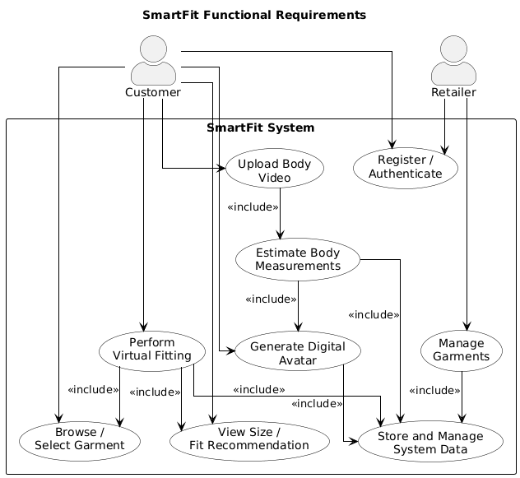

3.6.2 Non-Functional Requirements
Non-functional requirements define the quality attributes and operational characteristics of the proposed system.
- The system shall provide a responsive web interface that is accessible through modern desktop and mobile web browsers.
- The system shall authenticate users before granting access to protected system resources.
- The system shall ensure the confidentiality and integrity of user information by implementing secure storage and controlled access to sensitive data.
- The system shall provide reliable processing of uploaded videos and generate body measurement estimations within an acceptable response time under normal operating conditions.
- The system shall maintain high system availability and recover gracefully from unexpected failures or invalid user inputs.
- The system shall be modular to facilitate maintenance, testing, and future enhancement of individual system components.
- The system shall support scalability, allowing additional users, garments, and processing modules to be incorporated with minimal changes to the overall system architecture.
- The system shall maintain compatibility between the frontend, backend, computer vision module, visualization engine, and database to ensure seamless system integration.
- The system shall provide an intuitive and user-friendly interface that minimizes the learning curve for both customers and retailers.

Figure 14: System Non-Functional Requirements
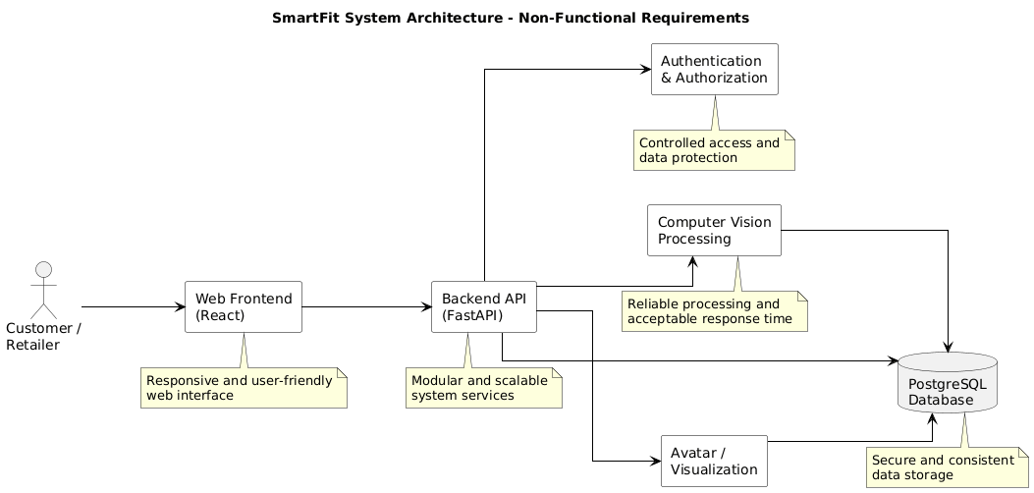

3.7 Requirement Analysis and Modelling
Requirement analysis and modelling provide a structured representation of the functional requirements of the proposed virtual fitting system. The process involves analysing the interactions between system users and the application, identifying the major system processes, and modelling the relationships among the various software components. These models serve as a blueprint for system development by providing a clear understanding of how the system is expected to operate before implementation.
The proposed system supports two primary categories of users:
- Customers
- Clothing retailers.
Customers interact with the system to register accounts, upload body videos, generate digital avatars, browse available garments, perform virtual fitting, and receive personalized size recommendations.
Retailers interact with the system to manage garment information by uploading clothing items, specifying garment dimensions, and maintaining product records. The system processes these interactions through the backend services, computer vision module, visualization engine, and database to deliver the required functionality.
To illustrate the behaviour and operation of the proposed system, Unified Modeling Language (UML) models are used. These models include use case diagrams to represent user interactions, activity diagrams to describe workflow processes, sequence diagrams to illustrate communication between system components, and class diagrams to represent the structural organization of the system. Collectively, these models provide a comprehensive representation of the proposed system and guide its implementation.

3.7.1 Use Case Analysis
Use case analysis was carried out to identify the interactions between the users and the proposed virtual fitting system. The analysis defines the functional services that the system provides and illustrates how different users interact with these services to accomplish specific tasks. It also establishes the system boundary by distinguishing activities performed by users from those performed automatically by the system.
The proposed system involves two primary actors:
- The Customer
- The Retailer.
Customers use the system to:
- Create user accounts
- Upload body videos
- Generate digital avatars
- Browse available garments
- Perform virtual fitting
- Receive size recommendations
- Manage their profiles.
These interactions enable customers to make informed purchasing decisions based on estimated body measurements and garment compatibility.
Retailers interact with the system by:
- Registering and managing their accounts,
- Uploading garment information,
- Specifying garment measurements and available sizes
- Updating product records
- Maintaining their clothing catalogue.
The garment information provided by retailers forms the basis for the size comparison and virtual fitting processes performed by the system.
The system itself is responsible for:
- Processing uploaded body videos,
- Estimating body measurements using computer vision techniques
- Generating digital avatars
- Comparing body measurements with garment dimensions
- Producing fitting visualizations together with appropriate size recommendations.

These automated processes support the interactions initiated by both customers and retailers and collectively deliver the core functionality of the proposed virtual fitting system.
The interactions identified through the use case analysis provide the foundation for the use case diagram presented in the following section, which graphically represents the functional relationship between the system and its users.

3.7.1.1 Use Case Diagram
The use case diagram provides a graphical representation of the interactions between the users and the proposed virtual fitting system. It illustrates the functional services offered by the system and identifies the responsibilities of each actor. The diagram also shows the internal processes that are automatically executed by the system through <<include>> relationships, demonstrating how body measurement estimation, avatar generation, measurement comparison, and size recommendation are integrated into the virtual fitting workflow.

Figure 15: Use Case Diagram for the Proposed Virtual Fitting System.
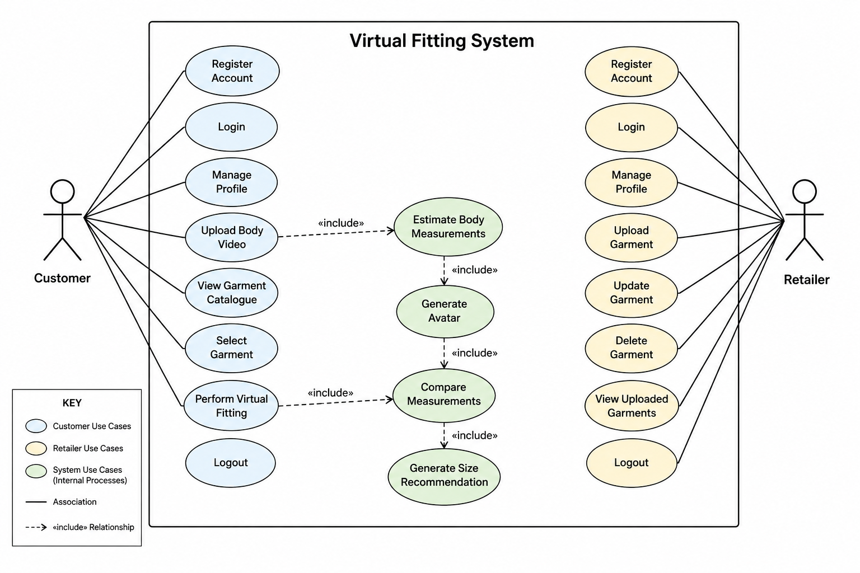

3.7.1.2 Use Case Descriptions
The following use case descriptions outline the primary functional processes of the proposed virtual fitting system. They describe the interactions between the system and its users, as well as the internal processes that support body measurement estimation, avatar generation, virtual fitting, and garment management.

USE CASE 1: Upload Body Video
FIELD | DESCRIPTION
Use Case Name | Upload Body Video
Primary Actor | Customer
Description | Allows the customer to upload a short rotational body video for body measurement estimation.
Pre Conditions | The customer is registered and logged into the system.
Main Flow | 1. The customer accesses the upload page.  2. The customer selects a body video.  3. The system validates the video format and quality.  4. The video is uploaded and stored.  5. The system forwards the video for body measurement estimation.
Alternative Flow | If the uploaded video is invalid or corrupted, the system displays an error message and prompts the customer to upload another video.
Post Conditions | The uploaded video is securely stored and available for processing.

Use Case 2: Estimate Body Measurements
FIELD | DESCRIPTION
Use Case Name: | Estimate Body Measurements
Primary Actor | System
Description | The system processes the uploaded body video to estimate the customer's body measurements using computer vision techniques.
Preconditions: | A valid body video has been uploaded.
Main Flow: | 1. The backend retrieves the uploaded video.  2. The computer vision module extracts video frames.  3. MediaPipe detects body landmarks.  4. The system estimates body measurements.  5. Estimated measurements are stored in the database.
Alternative Flow: | If body landmarks cannot be detected accurately, the system requests the customer to upload another video.
Post Conditions: | Estimated body measurements are successfully generated and stored.

Use Case 3: Generate Avatar
FIELD | DESCRIPTION
Use Case Name: | Generate Avatar
Primary Actor | System
Description | Generates a scaled digital avatar using the estimated body measurements.
Pre Conditions | Body measurements have been successfully estimated.
Main Flow | 1. The avatar generation module retrieves body measurements.  2. A digital avatar is created based on the measurements.  3. The avatar is saved in the database.  4. The avatar is displayed to the customer.
Alternative Flow | If avatar generation fails, the system notifies the customer and requests another body scan.
Post Conditions | A digital avatar representing the customer's body proportions is generated.

Use Case 4: Compare Measurements
FIELD | DESCRIPTION
Use Case Name: | Compare Measurements
Primary Actor | System
Description | Compares the customer's estimated body measurements with the measurements of the selected garment.
Pre Conditions | A digital avatar exists and a garment has been selected.
Main Flow | 1. The customer selects a garment.  2. The system retrieves garment measurements.  3. Customer measurements are compared with garment dimensions.  4. The fitting suitability is determined.
Alternative Flow | If garment measurements are incomplete, the comparison cannot be performed and the customer is notified.
Post Conditions | A fitting assessment is generated for the selected garment.

Use Case 5: Generate Size Recommendation
FIELD | DESCRIPTION
Use Case Name: | Generate Size Recommendation
Primary Actor | System
Description | Determines the most suitable garment size based on the comparison between customer body measurements and garment dimensions.
Pre Conditions | Body and garment measurements have been successfully compared.
Main Flow | 1. The recommendation engine analyses the comparison results.  2. The most appropriate clothing size is determined.  3. The recommendation is displayed to the customer.
Alternative Flow | If no suitable size is available, the system informs the customer that the selected garment may not fit.
Post Conditions | A personalized clothing size recommendation is generated.

Use Case 6: Perform Virtual Fitting
FIELD | DESCRIPTION
Use Case Name: | Perform Virtual Fitting
Primary Actor | Customer
Description | Allows the customer to visualize how the selected garment fits the generated digital avatar.
Pre Conditions | The customer is logged in, a digital avatar exists, and a garment has been selected.
Main Flow | 1. The customer selects a garment.  2. The system overlays the garment onto the digital avatar.  3. The virtual fitting visualization is rendered using Three.js.  4. The fitting result and size recommendation are displayed.
Alternative Flow | If rendering fails, the system informs the customer and allows another attempt.
Post Conditions | The customer views the virtual fitting visualization and recommended size.

Use Case 7: Upload Garment Information
FIELD | DESCRIPTION
Use Case Name: | Upload Garment Information
Primary Actor | Retailer
Description | Allows the retailer to upload garment details and measurement information into the system.
Pre Conditions | The retailer is registered and logged into the system.
Main Flow | 1. The retailer accesses the garment management page.  2. Garment details, images, dimensions, available sizes, and descriptions are entered.  3. The system validates the information.  4. The garment is stored in the database.  5. The garment becomes available in the customer catalogue.
Alternative Flow | If mandatory garment information is missing or invalid, the system displays an error message and requests correction before submission.

3.7.3Activity Diagrams
Activity diagrams are used to illustrate the workflow of the major processes performed by the proposed virtual fitting system. They provide a graphical representation of the sequence of activities, decision points, and interactions that occur as users perform different tasks within the system. These diagrams facilitate a clear understanding of how information flows through the system and how various components interact to accomplish specific functions.
The activity diagrams presented in this section model the key business processes of the proposed system, including body video upload and processing, virtual fitting and size recommendation, and garment management. Together, these diagrams illustrate the operational behaviour of the system and serve as a guide for implementation.

Figure 16: Activity Diagrams for the Proposed Virtual Fitting System.
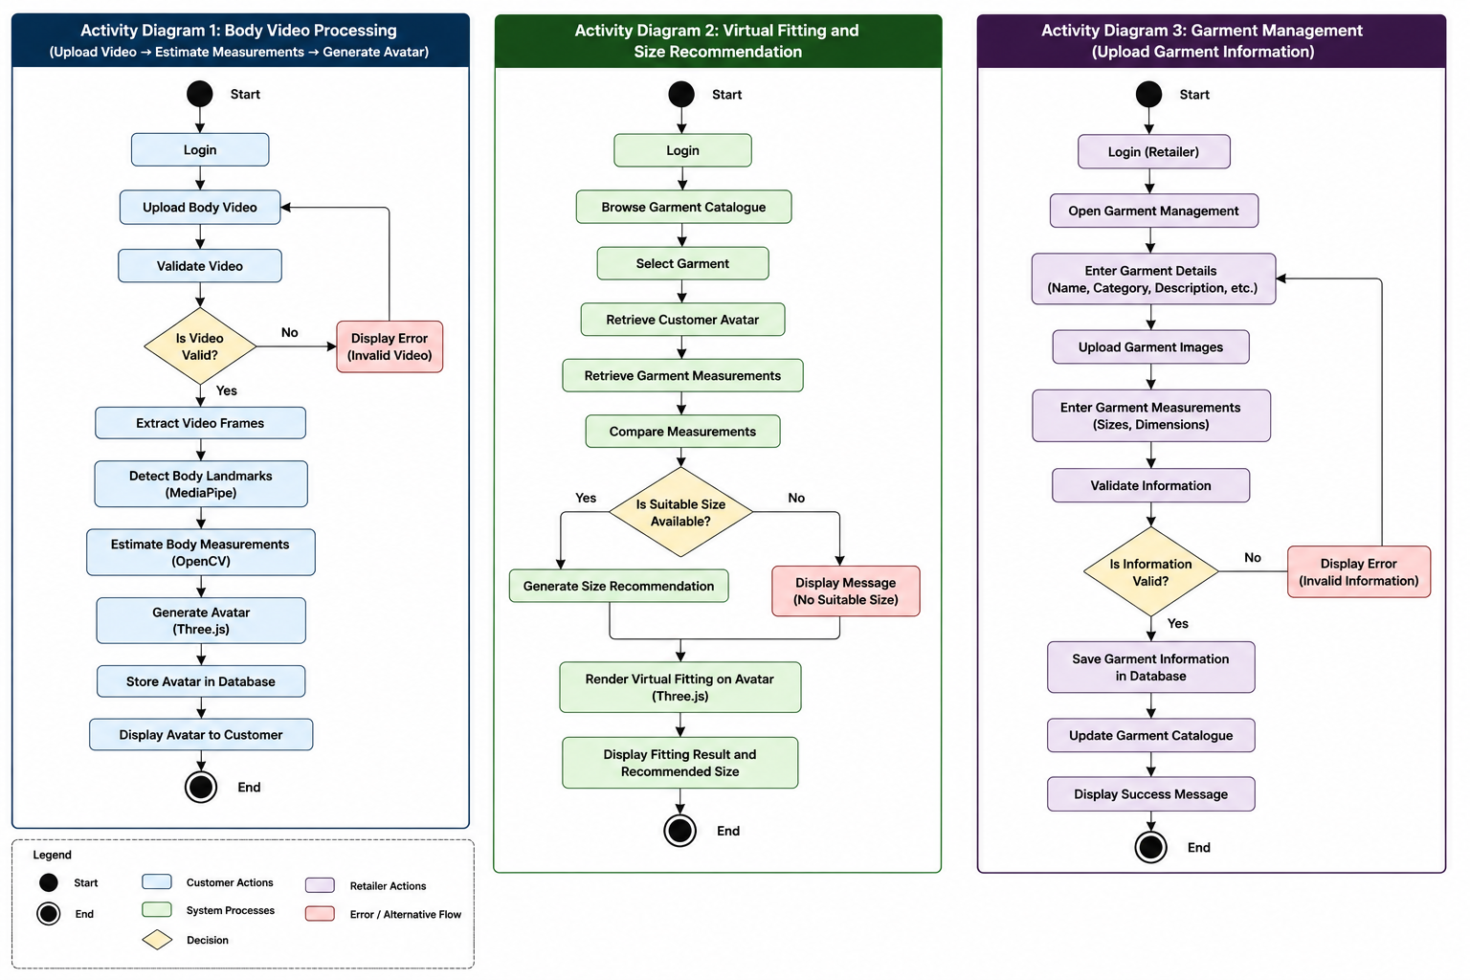

Use Case | Where Covered
Upload Body Video | Activity Diagram 1
Estimate Body Measurement | Activity Diagram 1
Generate Avatar | Activity Diagram 1
Compare Measurements | Activity Diagram 2
Generate Size Recommendations | Activity Diagram 2
Perform Virtual Fitting | Activity Diagram 2
Upload Garment Information | Activity Diagram 3

3.7.4 Sequence Diagrams

Sequence diagrams illustrate the chronological interaction between users and the various components of the proposed virtual fitting system during the execution of specific processes. Unlike activity diagrams, which focus on workflow, sequence diagrams emphasize the exchange of messages between system objects and the order in which these interactions occur. They provide a detailed view of how requests are processed from initiation to completion, thereby illustrating the dynamic behaviour of the system.
The proposed virtual fitting system comprises several interacting components, including the frontend application, backend server, computer vision processing module, avatar generation module, visualization engine, and database. Sequence diagrams are used to demonstrate how these components collaborate to accomplish the system's core functionalities, including user authentication, body measurement estimation, virtual fitting, and garment management.
The sequence diagrams presented in this section provide a detailed representation of the communication between system components and serve as a guide for implementing the interactions defined in the proposed system architecture.

Figure 17: Sequence diagram: User Authentication.
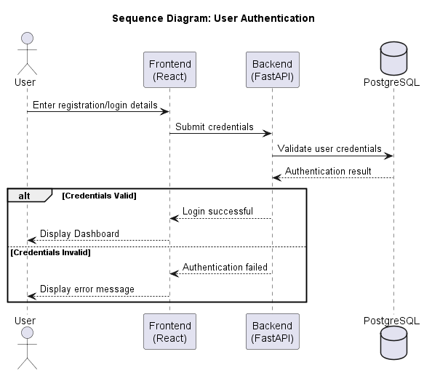

Figure 18: Sequence diagram: Virtual Fitting and Size Recommendation.
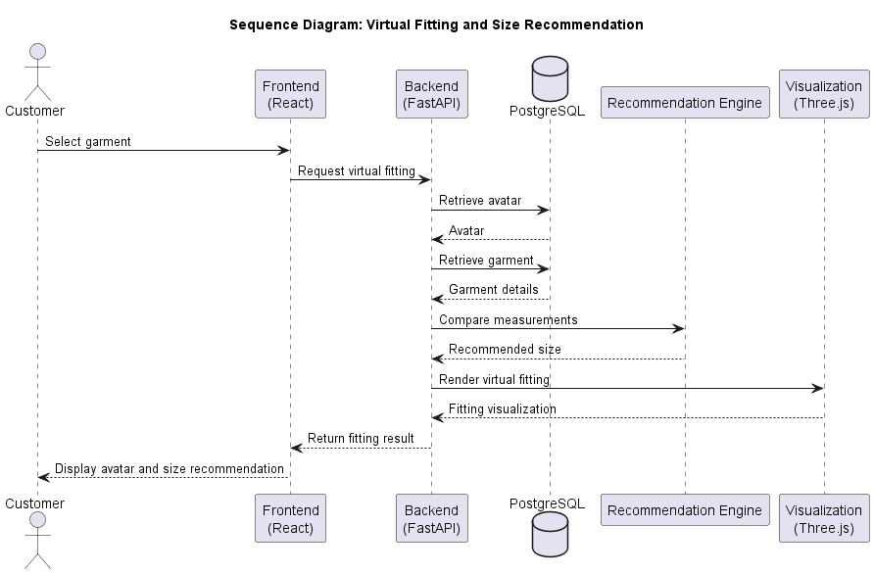

Figure 19: Sequence diagram: Body Measurement Estimation and Avatar Generation
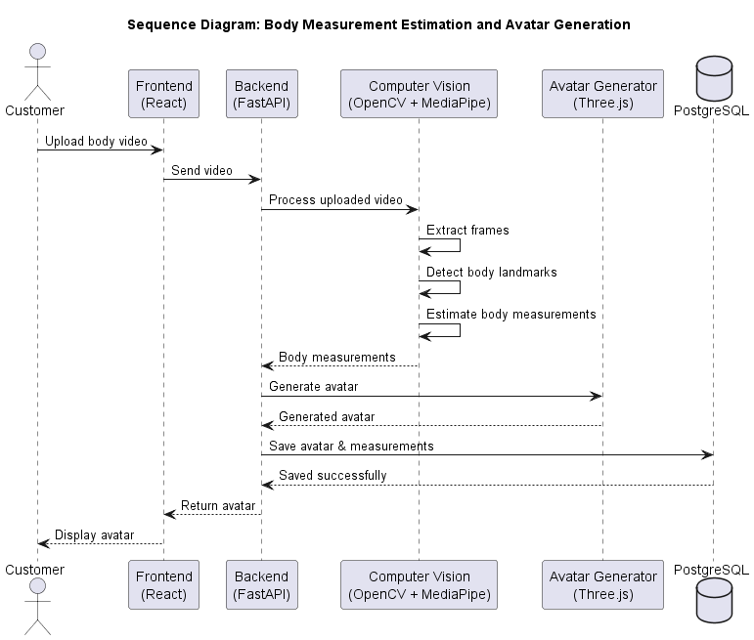

Figure 20: Sequence diagram: Garment upload and Management.
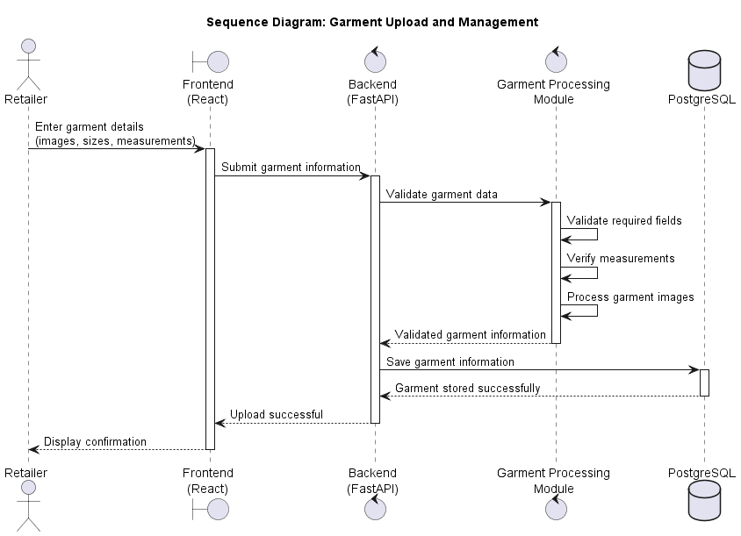

3.8 Logical Design
Logical design translates the system requirements identified during the analysis phase into a structured software design that guides system implementation. It defines the organization of the system into logical components, specifies how these components interact, and describes the flow of information between them. The logical design provides a technology-oriented view of the proposed virtual fitting system without focusing on physical deployment or implementation details.
The proposed system adopts a layered architecture that separates user interaction, application logic, computer vision processing, visualization, and data management into independent modules. This modular organization promotes maintainability, scalability, and flexibility by ensuring that each component performs a well-defined responsibility while communicating with other components through clearly defined interfaces.
The logical design presented in this section builds upon the system requirements and UML models discussed earlier and serves as the blueprint for implementing the proposed virtual fitting system.

Figure 21: Logical Architecture of the proposed virtual fitting system
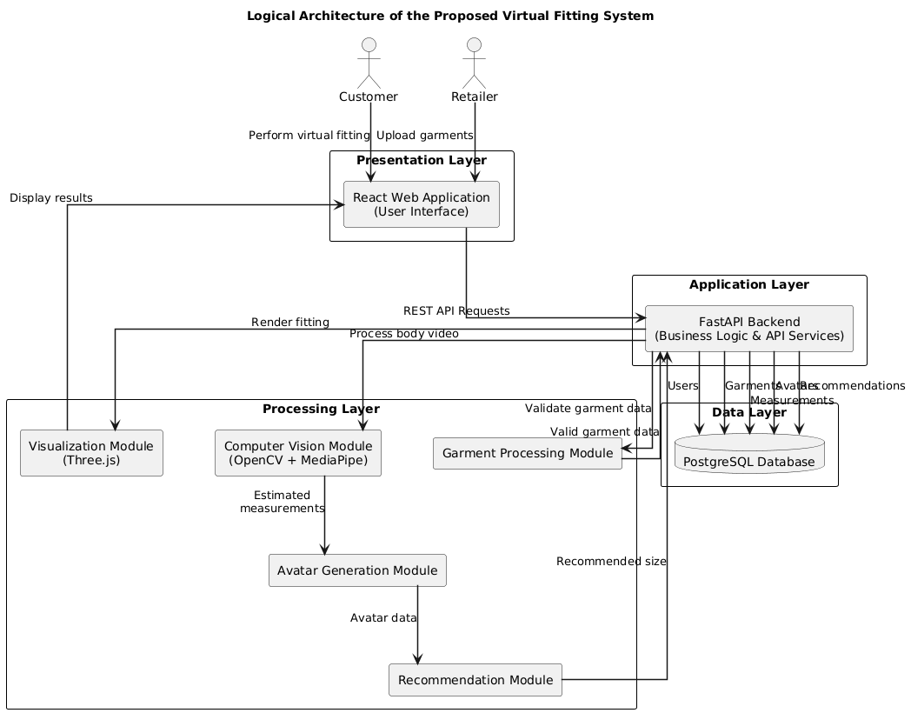

3.8.1 System Architecture
The logical architecture of the proposed virtual fitting system adopts a layered client-server design that organizes the application into independent functional layers. Each layer performs a specific responsibility while interacting with adjacent layers through well-defined interfaces. This separation of concerns improves system maintainability, facilitates future enhancements, and allows individual components to be modified without significantly affecting the overall system.
The architecture consists of four primary layers:
- The Presentation Layer
- Application Layer
- Processing Layer
- Data Layer.
User requests originate from the presentation layer and are forwarded to the application layer, where business logic and system coordination are performed. The application layer communicates with the processing layer to perform body measurement estimation, avatar generation, garment comparison, and size recommendation.
Processed information is then stored or retrieved from the data layer before the results are returned to the user through the presentation layer.

Presentation Layer
The presentation layer provides the graphical user interface through which customers and retailers interact with the system. Developed using React, this layer enables users to register accounts, authenticate themselves, upload body videos, manage garment information, browse the garment catalogue, perform virtual fitting, and view personalized size recommendations. The presentation layer communicates with the backend exclusively through RESTful API requests.
Figure 22: Presentation layer of the proposed virtual fitting system
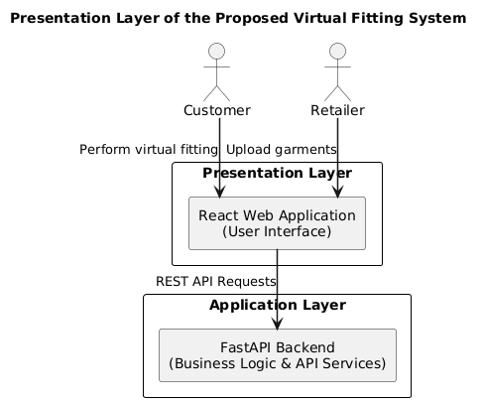
Application Layer
The application layer is implemented using FastAPI and serves as the central coordinator of the system. It manages user authentication, request validation, business logic, API communication, session management, and interaction between the frontend, processing modules, and database. This layer ensures that user requests are processed efficiently and routed to the appropriate system components.
Figure 23: Application layer of the proposed virtual fitting system
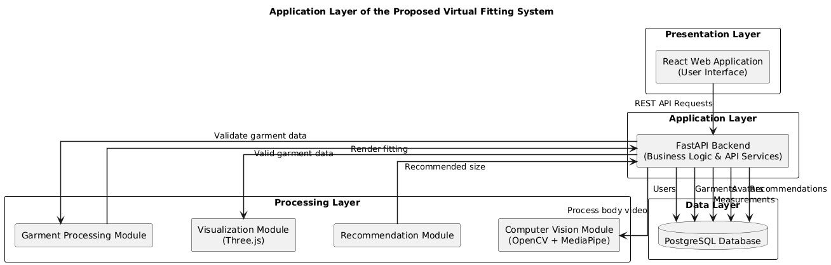

Processing Layer
The processing layer contains the specialized modules responsible for the core functionality of the virtual fitting system. The Computer Vision Module utilizes OpenCV and MediaPipe to process uploaded body videos, detect body landmarks, and estimate body measurements. The Avatar Generation Module uses the estimated measurements to create a scaled digital avatar, while the Recommendation Module compares user body measurements with garment dimensions to determine the most suitable clothing size. The Visualization Module, implemented using Three.js, renders the digital avatar together with the selected garment to provide an approximate virtual fitting experience.
Figure 24: Processing layer of the proposed virtual fitting system
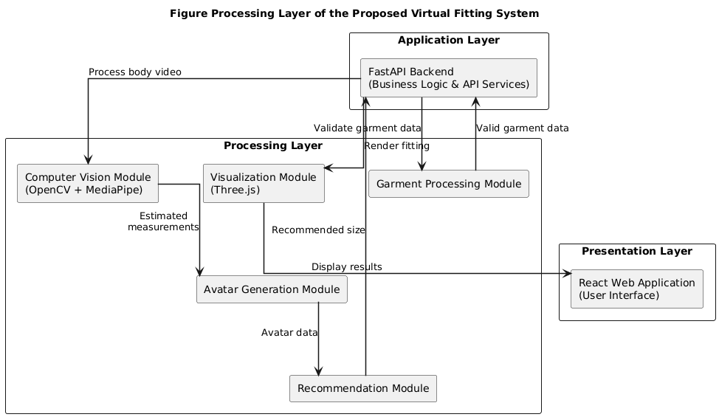

Data Layer
The data layer is implemented using PostgreSQL and provides persistent storage for system information. It maintains customer and retailer accounts, uploaded body videos, estimated body measurements, avatar metadata, garment information, garment measurements, fitting recommendations, and other system records. The database supports secure data retrieval and storage while ensuring consistency and integrity across all system operations.

Figure 25: Data layer of the proposed virtual fitting system
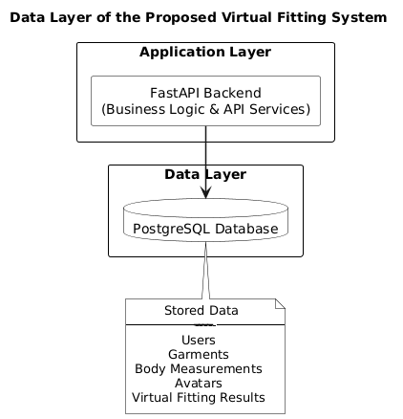

3.8.2 Control Flow and Process Design
Control flow and process design describe the sequence of activities performed by the proposed virtual fitting system during the execution of its core functions. It defines how requests are initiated, processed, and completed while illustrating the interactions between users and the various software modules. The control flow ensures that each operation is executed in a logical sequence, enabling efficient communication between the presentation layer, application layer, processing modules, and database.
The proposed system consists of two primary operational workflows: the customer virtual fitting process and the retailer garment management process. Each workflow comprises a series of coordinated activities that are managed by the backend application and supported by the computer vision, recommendation, visualization, and database components. The activity diagrams and sequence diagrams presented in Section 3.7 provide a graphical representation of these workflows, while the following discussion explains the control logic governing their execution.

3.8.2.1 Customer Virtual Fitting Process

The customer virtual fitting process begins when a registered user logs into the system through the web application. After successful authentication, the customer uploads a short rotational body video, which is transmitted to the backend server for processing. The backend forwards the uploaded video to the computer vision module, where video frames are extracted, body landmarks are detected, and body measurements are estimated using OpenCV and MediaPipe technologies.
The estimated body measurements are then passed to the avatar generation module, which creates a scaled digital representation of the customer's body. Once the avatar has been generated, the customer selects a garment from the available catalogue. The backend retrieves the corresponding garment measurements from the database and invokes the recommendation module to compare the customer's body measurements with the garment dimensions. Based on the comparison results, the system determines the most appropriate clothing size and forwards the recommendation to the visualization module.
Finally, the visualization module renders the selected garment on the generated avatar using Three.js technologies and returns the virtual fitting result to the frontend, where it is displayed to the customer together with the recommended clothing size. This process ensures that users receive personalized fitting recommendations while minimizing uncertainty during online clothing purchases.

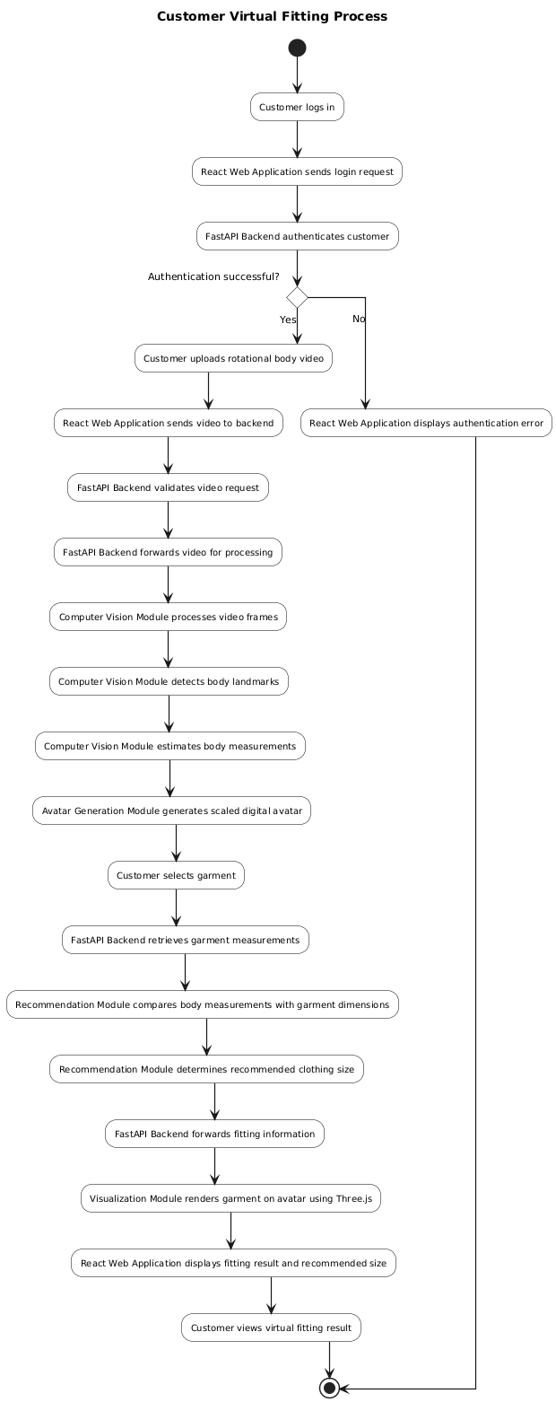
Figure 26: Retailer Garment Management Process

3.8.2.2 Retailer Garment Management Process

The retailer garment management process enables clothing retailers to register and maintain garment information within the system. After successful authentication, the retailer accesses the garment management interface and enters garment details, including garment images, dimensions, available sizes, and other descriptive information.
The submitted data is transmitted to the backend server, which forwards it to the garment processing module for validation. The module verifies that all mandatory information has been provided, validates the entered measurements, and ensures that uploaded images satisfy the required format and quality standards. Upon successful validation, the processed garment information is returned to the backend, which stores the records in the PostgreSQL database.
Once the garment has been successfully saved, the updated information becomes immediately available within the system, allowing customers to browse the garment catalogue and perform virtual fitting using the newly uploaded clothing items.

Figure 27: Retailer Garment Management Process
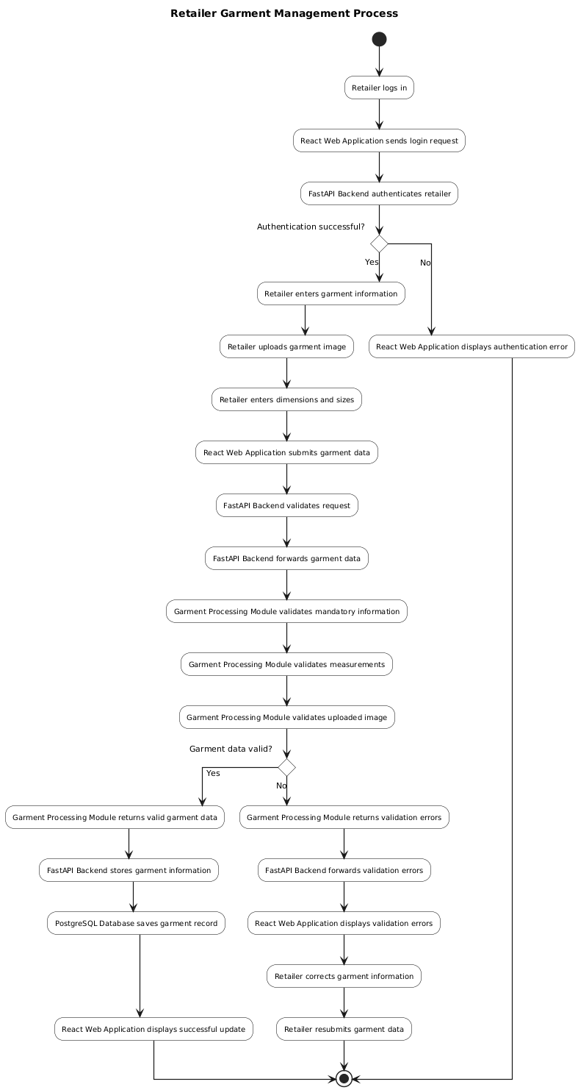

3.8.2.3 System Control Logic

The FastAPI backend serves as the central control component of the proposed virtual fitting system. It coordinates communication between the frontend application, processing modules, and database while ensuring that requests are executed in the correct sequence. All user requests are first received by the backend, where authentication, request validation, and business logic are applied before forwarding the requests to the appropriate processing module.
The backend is also responsible for managing interactions with the PostgreSQL database by storing and retrieving user accounts, garment information, body measurements, avatar metadata, and fitting recommendations. This centralized control approach enhances system security, maintains data consistency, and simplifies communication between system components by preventing direct interaction between the frontend application and the database.

Figure 28: System Control Logic
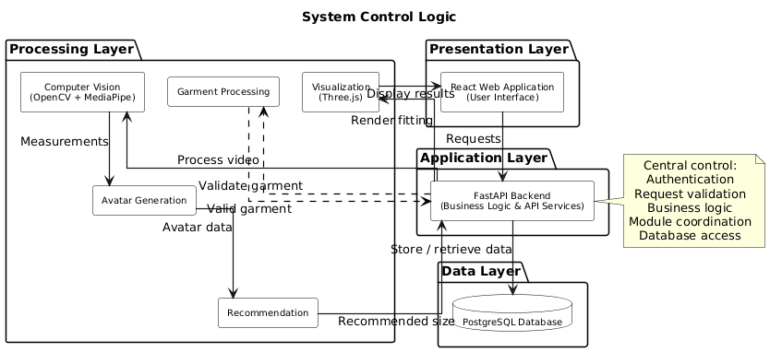

3.8.2.4 Exception Handling

The proposed system incorporates validation and exception handling mechanisms to ensure reliable operation and improve user experience. During body video upload, the system verifies the uploaded file format and rejects unsupported or corrupted files before processing begins. Similarly, garment information submitted by retailers is validated to ensure that all mandatory fields, measurements, and images are provided before the records are stored.
Authentication failures, invalid user inputs, and processing errors are handled by the backend application, which returns descriptive error messages to the frontend for display to users. Where appropriate, users are prompted to correct the identified errors and resubmit their requests. These validation and error-handling procedures contribute to the robustness, reliability, and overall usability of the proposed virtual fitting system.

Figure 29: Exception Handling and Validation Flow
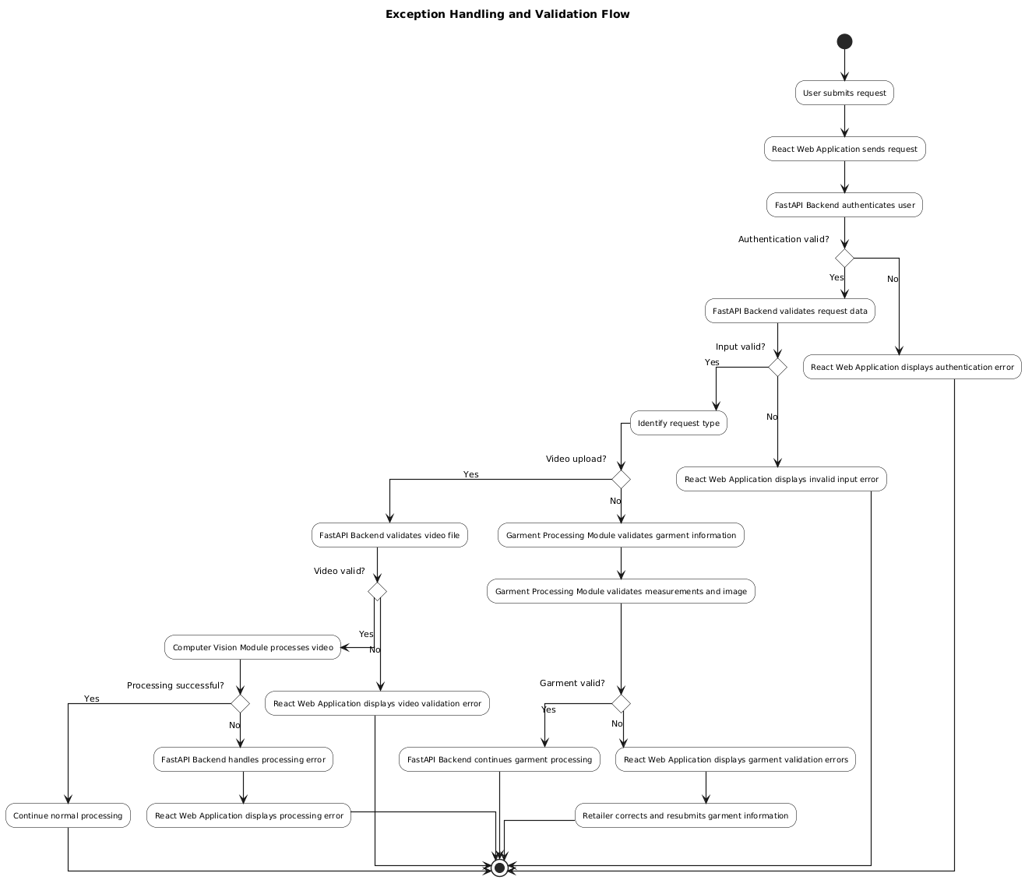

3.8.3 Design for Non-Functional Requirements

The proposed virtual fitting system incorporates several non-functional design considerations to ensure that it operates securely, reliably, efficiently, and provides a satisfactory user experience. These considerations have been integrated into the system architecture to complement the functional requirements and improve the overall quality of the application. The major design strategies adopted include security, error and exception handling, performance optimization, scalability, maintainability, and usability.

3.8.3.1 Security Design
Security has been integrated into the proposed system through multiple mechanisms designed to protect user information and prevent unauthorized access. User authentication is implemented using FastAPI, with user credentials securely stored in PostgreSQL after being hashed using the bcrypt hashing algorithm. During login, submitted passwords are verified against their hashed equivalents rather than being stored or compared in plain text.
Following successful authentication, the backend issues JSON Web Tokens (JWTs) to authenticated users. These tokens are used to authorize subsequent requests and ensure that only authenticated users can access protected resources. In addition, role-based access control (RBAC) is implemented to distinguish between customers and retailers. Customers are authorized to upload body videos, perform virtual fitting, and receive size recommendations, while retailers are granted privileges to upload and manage garment information.
Communication between the React frontend and the FastAPI backend is performed through secure RESTful APIs. All incoming requests are validated using Pydantic models before processing to ensure that submitted data conforms to the expected structure and constraints. Uploaded body videos and garment images are validated for supported file formats, acceptable file sizes, and completeness before they are forwarded to the processing modules. Furthermore, direct access to the PostgreSQL database is restricted to the backend application, ensuring that all database operations are performed through controlled and authenticated API requests.
Figure 30: Security Design
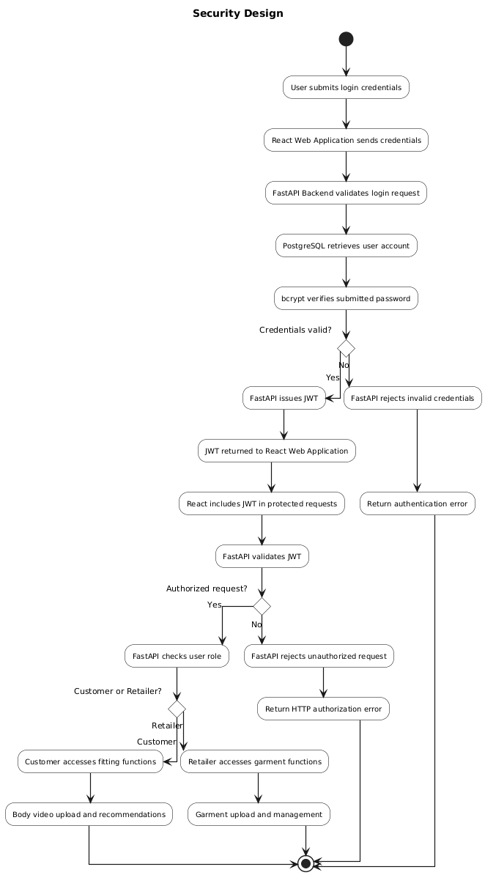

3.8.3.2 Error and Exception Handling
The proposed system incorporates comprehensive validation and exception handling mechanisms to ensure reliable operation under different usage conditions. Validation is performed at both the frontend and backend to verify that mandatory fields are completed before processing begins. React provides immediate client-side validation to improve user experience, while FastAPI performs server-side validation using Pydantic to guarantee data integrity regardless of the client environment.
During body video processing, the computer vision module implemented using OpenCV and MediaPipe verifies that uploaded videos are readable and compatible with supported processing formats before body landmark detection is initiated. Similarly, garment information submitted by retailers is validated to ensure that garment dimensions, available sizes, and uploaded images satisfy the required specifications.
Exceptions arising from database operations, file uploads, or processing failures are handled centrally by FastAPI's exception handling mechanisms. Instead of exposing internal system errors, the backend returns meaningful HTTP status codes and descriptive error messages that enable users to correct invalid inputs. System errors and unexpected exceptions are recorded using Python logging facilities to support debugging, monitoring, and future maintenance.

Figure 31: Error and Exception Handling
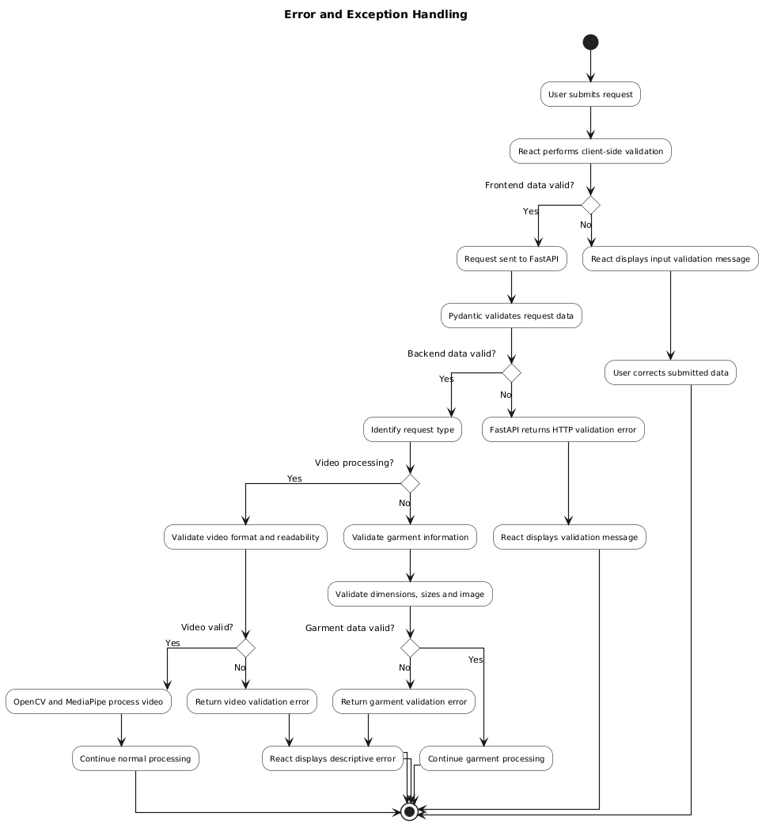

3.8.3.3 Design for Performance, Maintainability and Scalability
The proposed system adopts a modular layered architecture consisting of presentation, application, processing, and data layers. This separation of responsibilities minimizes coupling between software components, making the system easier to maintain, test, and extend.
FastAPI has been selected as the backend framework because of its asynchronous request handling capabilities, which allow the system to process multiple user requests efficiently. PostgreSQL provides reliable and efficient storage for user accounts, garment information, body measurements, avatar metadata, and fitting records while supporting indexing and optimized query execution for improved retrieval performance.
Within the processing layer, OpenCV and MediaPipe analyse only the video frames required for body landmark detection, reducing unnecessary computational overhead. The modular architecture also enables future integration of enhanced computer vision algorithms, machine learning-based recommendation models, or additional visualization capabilities without requiring significant modifications to the remaining system components.

Figure 32: Performance, Maintainability and Scalability Design
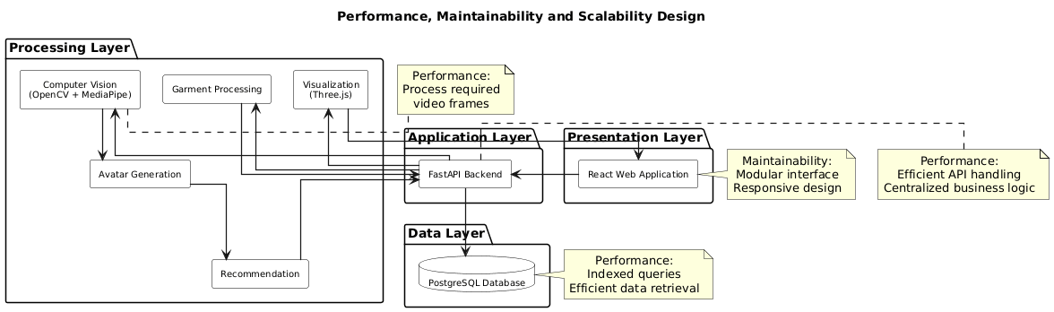

3.8.3.4 Design for Usability and User Experience
The system has been designed to provide an intuitive, responsive, and user-friendly interface for both customers and retailers. The frontend is implemented using React, enabling the development of dynamic and responsive web interfaces that adapt to different screen sizes and devices.
Customers are guided through a simple workflow comprising user authentication, body video upload, avatar generation, garment selection, virtual fitting, and size recommendation. Retailers are provided with dedicated interfaces for uploading garment information, managing product catalogues, and updating garment records. Consistent navigation, informative feedback messages, and clear validation prompts reduce user errors and improve overall system usability.
The visualization module utilizes Three.js to render three-dimensional avatars and virtual fitting results directly within the web browser. This interactive visualization enhances user engagement by allowing customers to view an approximate representation of how selected garments fit their generated avatars before making purchasing decisions.

Figure 33: Usability and User Experience
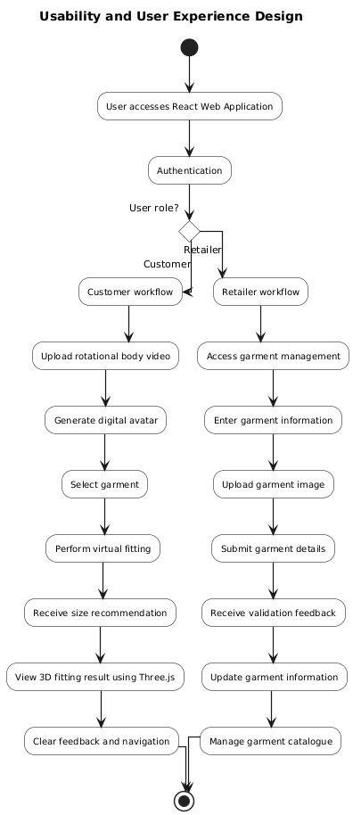

3.9 Physical Design
Physical design translates the logical system design into implementable software and database structures. It specifies how the proposed virtual fitting system will be physically realized through database organization, user interface layouts, and software components. While the logical design describes the interaction between system modules, the physical design focuses on the concrete structures that support system implementation.
The physical design of the proposed system consists of two major components: the database design and the user interface design. The database design defines the data entities, relationships, and storage structures required to support the system's operations, while the user interface design specifies the screens through which customers and retailers interact with the application. Together, these components provide the foundation for implementing the proposed virtual fitting system.

3.9.1 Database Design

The database design defines the structure used to store, organize, and retrieve information required by the proposed virtual fitting system. A well-designed database ensures data consistency, integrity, and efficient access to information while supporting the various functional requirements of the system.
The proposed system utilizes PostgreSQL as its database management system due to its reliability, scalability, and support for relational data modelling. The database stores customer and retailer accounts, garment information, body measurements, avatar records, and virtual fitting sessions. Relationships between these entities are established using primary and foreign keys to maintain referential integrity and minimize data redundancy.
The Entity Relationship Diagram (ERD) presented in this section illustrates the major database entities and the relationships that exist between them. These entities provide the foundation for implementing the data layer of the proposed virtual fitting system.

3.9.1.1 Entity Relationship Diagram (ERD)
The Entity Relationship Diagram (ERD) illustrates the logical structure of the database for the proposed virtual fitting system. It identifies the major entities, their attributes, and the relationships established between them to support the system's functionality. The database consists of six primary entities: Users, Videos, BodyMeasurements, Avatars, Garments, and VirtualFittings. These entities are linked through primary and foreign key relationships to ensure data integrity, minimize redundancy, and support efficient data retrieval. The ERD serves as the blueprint for implementing the PostgreSQL database used by the system.
Figure 34: Entity Relationship Diagram for the proposed virtual fitting system
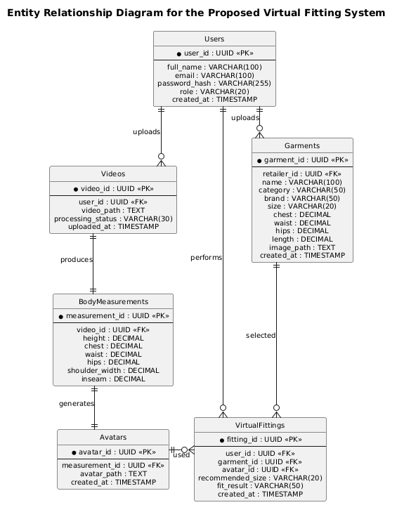

3.9.1.2 Entity Descriptions
The proposed virtual fitting system consists of six primary database entities that collectively support user management, garment management, body measurement estimation, avatar generation, and virtual fitting. Each entity has been designed to represent a specific aspect of the system while maintaining appropriate relationships with other entities to ensure data consistency and minimize redundancy.

Users
The Users entity stores account information for all registered users of the system. It accommodates both customers and retailers, with each user assigned a specific role that determines the functions they are authorized to perform. Customers are able to upload body videos and perform virtual fittings, while retailers can upload and manage garment information.
Figure 35: User Entity
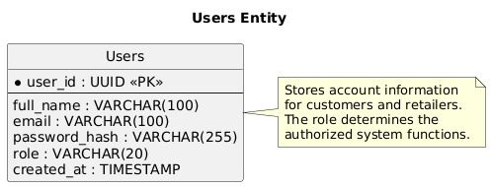

Videos
The Videos entity stores information about body videos uploaded by customers. Each uploaded video is associated with a single customer and serves as the source for body measurement estimation. In addition to storing the video location, the entity records the processing status and upload timestamp to facilitate video processing and monitoring.
Figure 36: Videos Entity
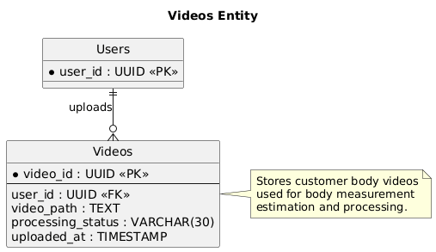

BodyMeasurements
The BodyMeasurements entity stores the body measurements extracted from uploaded videos using the computer vision module. These measurements include body dimensions such as height, chest, waist, hips, shoulder width, and inseam, which are subsequently used for avatar generation and garment size comparison.
Figure 37: Body Measurements Entity
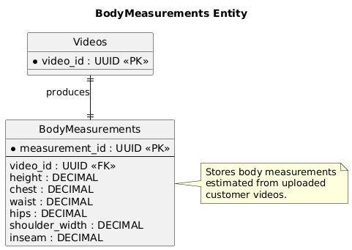

Avatars
The Avatars entity stores metadata relating to the digital avatars generated from the extracted body measurements. Each avatar corresponds to a single body measurement record and is used during the virtual fitting process to provide a visual representation of the customer.
Figure 38: Avatars Entity
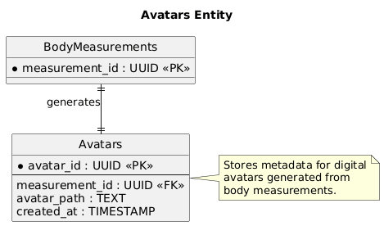

Garments
The Garments entity stores clothing information uploaded by retailers. The entity includes garment descriptions, categories, available sizes, dimensions, images, and retailer ownership information. These records form the catalogue from which customers select garments for virtual fitting.
Figure 39: Garments Entity
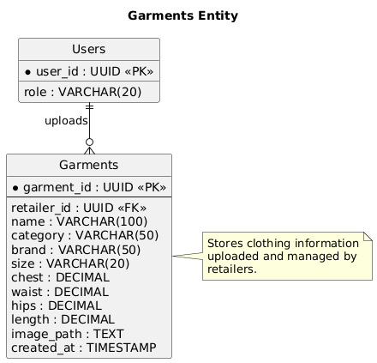

VirtualFittings
The VirtualFittings entity records every virtual fitting performed within the system. Each record links a customer, a selected garment, and the generated avatar used during the fitting process. The entity also stores the recommended clothing size, fitting result, and the date on which the fitting was performed. This information provides a history of fitting activities and supports future system analysis.
Figure 40: Virtual Fittings Entity
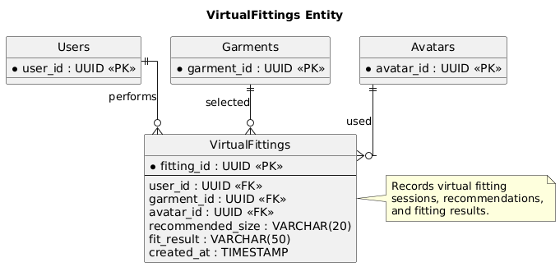

3.9.1.3 Data Dictionary
The data dictionary provides a detailed description of the attributes contained within each database entity. It specifies the data type, key constraints, and purpose of every attribute used in the proposed virtual fitting system.

 |  | User Entity
Attribute | Data Type | Key | Description
user_id | UUID | PK | Unique identifier for each user.
full_name | VARCHAR(100) |  | Full name of the registered user.
email | VARCHAR(100) | Unique | Email address used for authentication.
password_hash | VARCHAR(255) |  | Hashed user password using bcrypt.
role | VARCHAR(20) |  | User role (Customer or Retailer).
created_at | TIMESTAMP |  | Date and time the account was created

 |  | Video Entity
Attribute | Data Type | Key | Description
video_id | UUID | PK | Unique identifier for each uploaded video.
user_id | UUID | FK | References the customer who uploaded the video.
video_path | TEXT |  | Storage path of the uploaded body video.
processing_status | VARCHAR(30) |  | Current processing state (Pending, Processing, Completed, Failed).
uploaded_at | TIMESTAMP |  | Date and time the video was uploaded.

 |  | Body MeasurementEntity
Attribute | Data Type | Key | Description
measurement_id | UUID | PK | Unique identifier for the measurement record..
video_id | UUID | FK | References the processed video.
height | DECIMAL(5,2) |  | Estimated Body Height
chest | DECIMAL(5,2) |  | Estimated Chest Circumference
Waist | DECIMAL(5,2) |  | Estimated Waist Circumference
hips | DECIMAL(5,2) |  | Estimated hip circumference
shoulder_width | DECIMAL(5,2) |  | Estimated Shoulder Width
inseam | DECIMAL(5,2) |  | Estimated Inseam Length

 |  | Avatars Entity
Attribute | Data Type | Key | Description
avatar_id | UUID | PK | Unique identifier for each generated avatar
measurement_id | UUID | FK | References the associated body measurement
avatar_path | TEXT |  | Storage path of the generated avatar model
created_at | TIMESTAMP |  | Date and Time the avatar was generated

 |  | Garments Entity
Attribute | Data Type | Key | Description
garment_id | UUID | PK | Unique identifier for each garment
retailer_id | UUID | FK | Reference the retailer who uploaded the garment
name | VARCHAR(100) |  | Name of the garment
category | VARCHAR(500) |  | Garment category(eg shirt, dress…)
brand | VARCHAR(500) |  | Manufacturer or clothing brand
size | VARCHAR(200) |  | Available garment size
chest | DECIMAL(5,2) |  | Garment chest measurement (cm)
waist | DECIMAL(5,2) |  | Garment waist measurement (cm)
hips | DECIMAL(5,2) |  | Garment hip measurement (cm)
Length | DECIMAL(5,2) |  | Garment length (cm)
image_path | TEXT |  | Storage path of the garment image
created_at | TIMESTAMP |  | Date and time the garment was uploaded

 |  | Virtual Fitting Entity
Attribute | Data Type | Key | Description
fitting_id | UUID | PK | Unique identifier for each virtual fitting
user_id | UUID | FK | Reference the customer performing the fitting
garment_id | UUID | FK | Reference the selected garment
avatar_id | UUID | FK | Reference the generated avatar
Recommended_size | VARCHAR(20) |  | Recommended clothing size
fit_result | VARCHAR(50) |  | Result of the fitting analysis (e.g., Good Fit, Tight, Loose).
created_at | TIMESTAMP |  | Date and time the virtual fitting was performed

3.9.2 User Interface Design

3.9.2.1 Introduction
The user interface design defines the visual layout and interaction mechanisms through which customers and retailers access the proposed virtual fitting system. The interfaces have been designed to provide a simple, intuitive, and responsive user experience while supporting the functional requirements identified during system analysis. The frontend of the system will be implemented using React, enabling responsive web pages that can be accessed from both desktop and mobile web browsers.
The user interface consists of dedicated screens for user authentication, customer virtual fitting, retailer garment management, and visualization of fitting results. Each interface is designed to minimize user effort by providing clear navigation, informative feedback, and consistent layouts throughout the application.

3.9.2.2 Home Page
Figure 41: Home Page



3.9.2.3 User Registration Interface
Figure 42: User Registration Interface



3.9.2.4 User Login Interface
Figure 43: User Login Interface

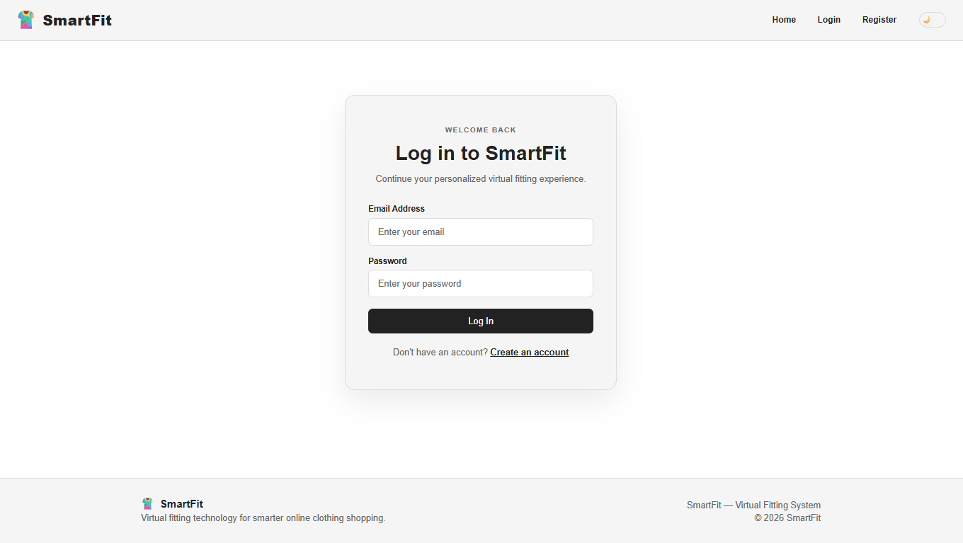

3.9.2.5 Customer Dashboard Interface
Figure 44: Customer Dashboard Interface



3.9.2.6 Video Upload Interface
Figure 45: Video Upload Interface

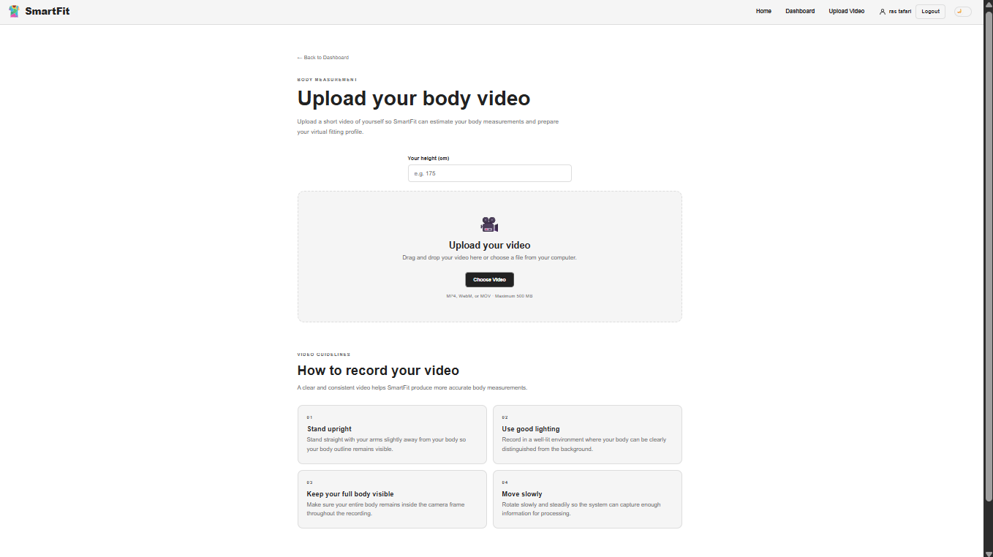

3.9.2.7 Video Processing Interface
Figure 46: Video Processing Interface
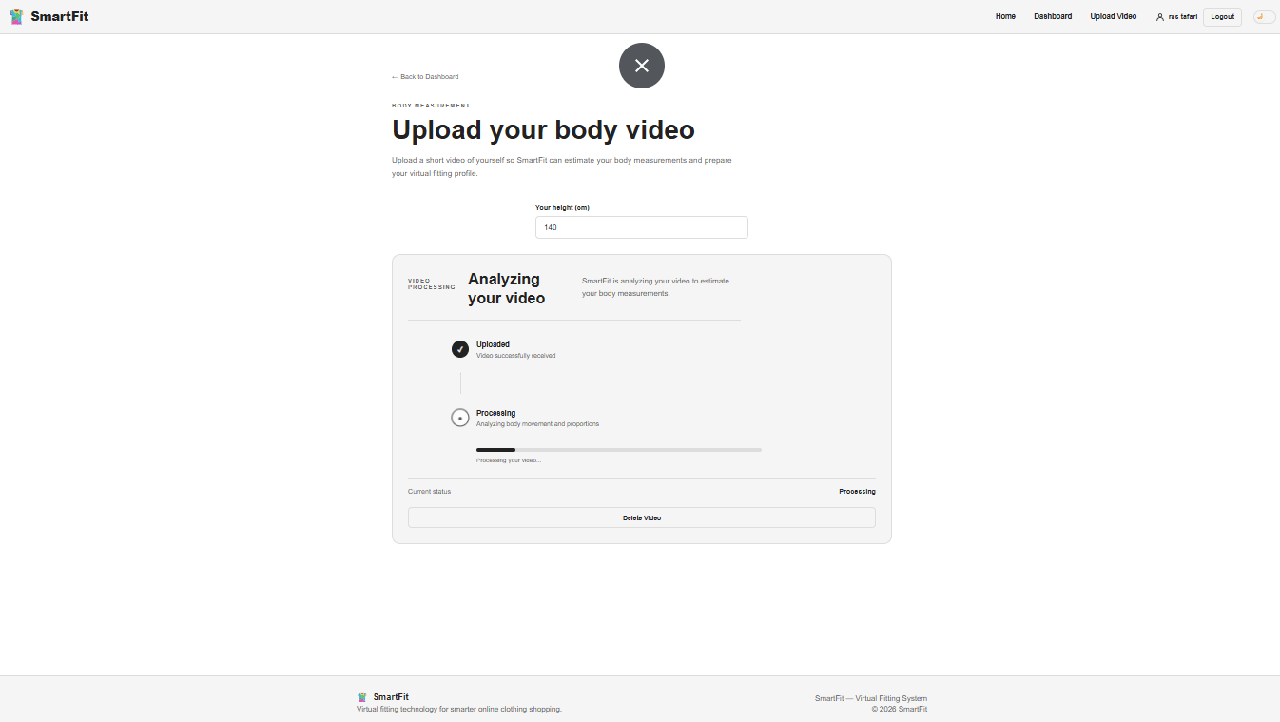

3.9.2.8 Avatar Generation Interface
Figure 47: Avatar Generation Interface

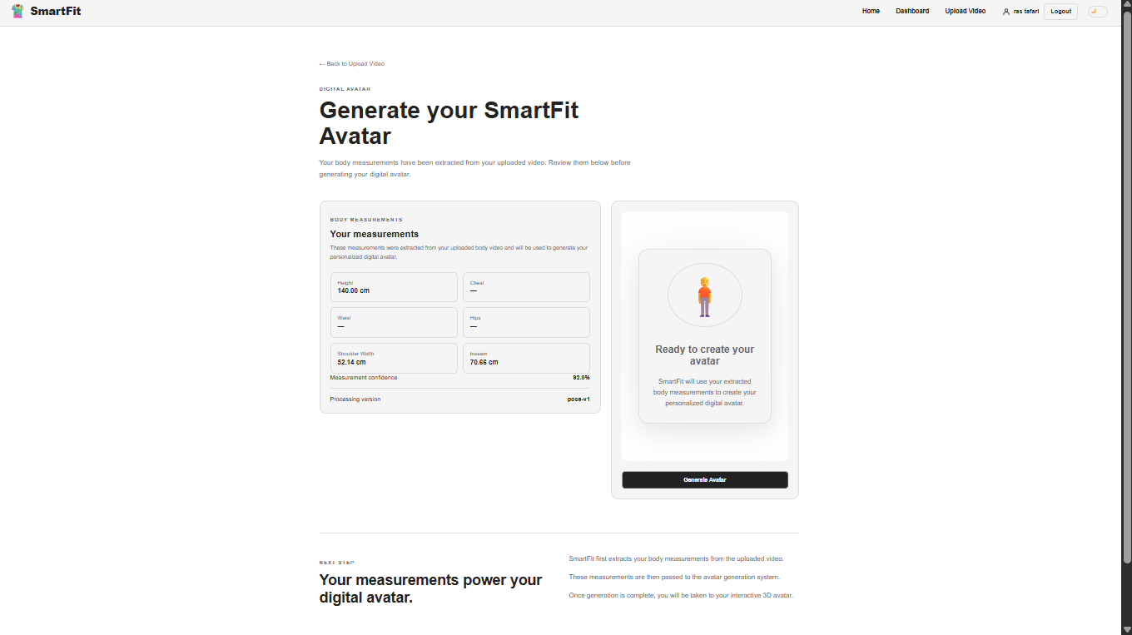

3.9.2.9 Virtual Fitting Interface
Figure 48: Virtual Fitting Interface

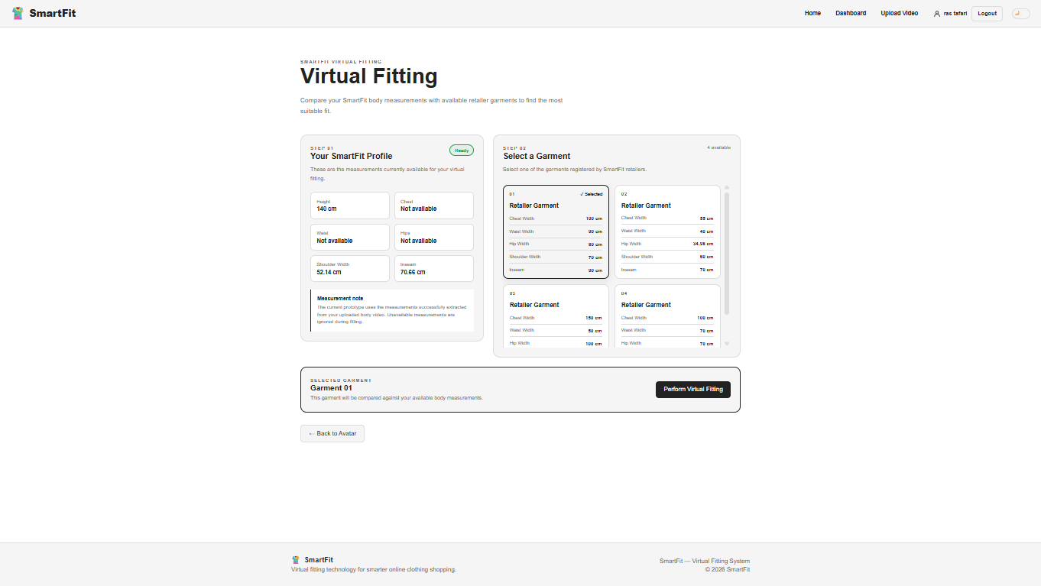

3.9.2.10 Retailer Dashboard Interface
Figure 49: Retailer Dashboard Interface
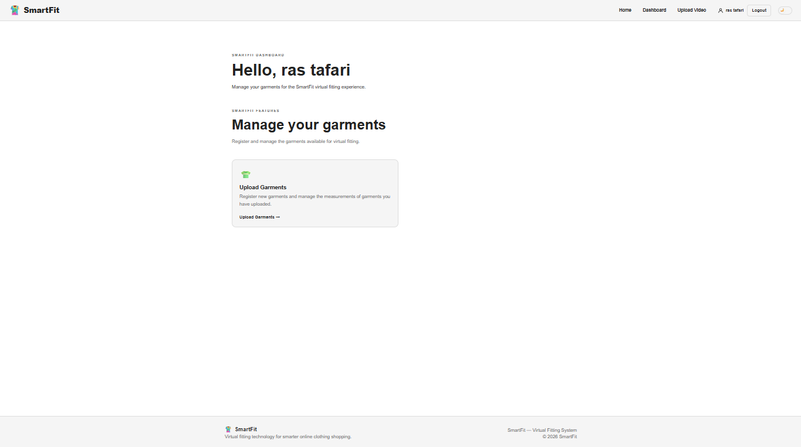

3.9.2.11 Garment Upload & Management Interface
Figure 50: Garment Upload & Management Interface
